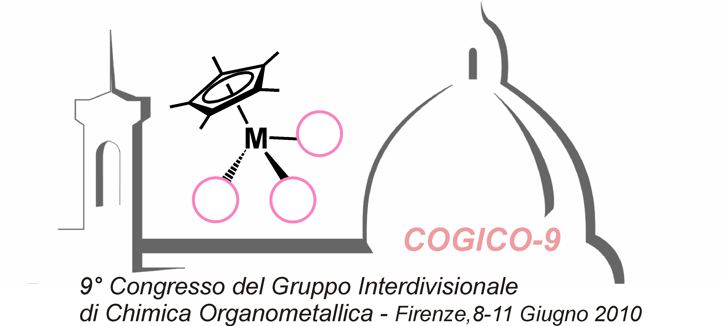

Registration Form

Last name: ................................... First name(s):. ......................................
􀁻 Mr. 􀁻 Ms. 􀁻 Dr. 􀁻 Prof.

Affiliation:
.......................................................................................................................
Address:
.......................................................................................................................

Daytime phone: .................................. Fax: ..............................................
E-mail: ..........................................................................................................

Travel information:
Arrival details:.. ..............................................................................................
Departure: ......................................................................................................

􀁻 Oral presentation
􀁻 Poster presentation

􀁻 Title: .........................................................................................................

Please save registration form as name.surname_reg_cogico9.doc and send to:
Dr. Luca Gonsalvi, ICCOM-CNR, Via Madonna del Piano 10, 50019 Sesto Fiorentino (FI), Italy
Fax: +39 055 5225203
email: cogico9@iccom.cnr.it

