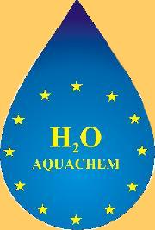

AQUACHEM
Transition Metal Chemistry and Catalysis in Aqueous Media

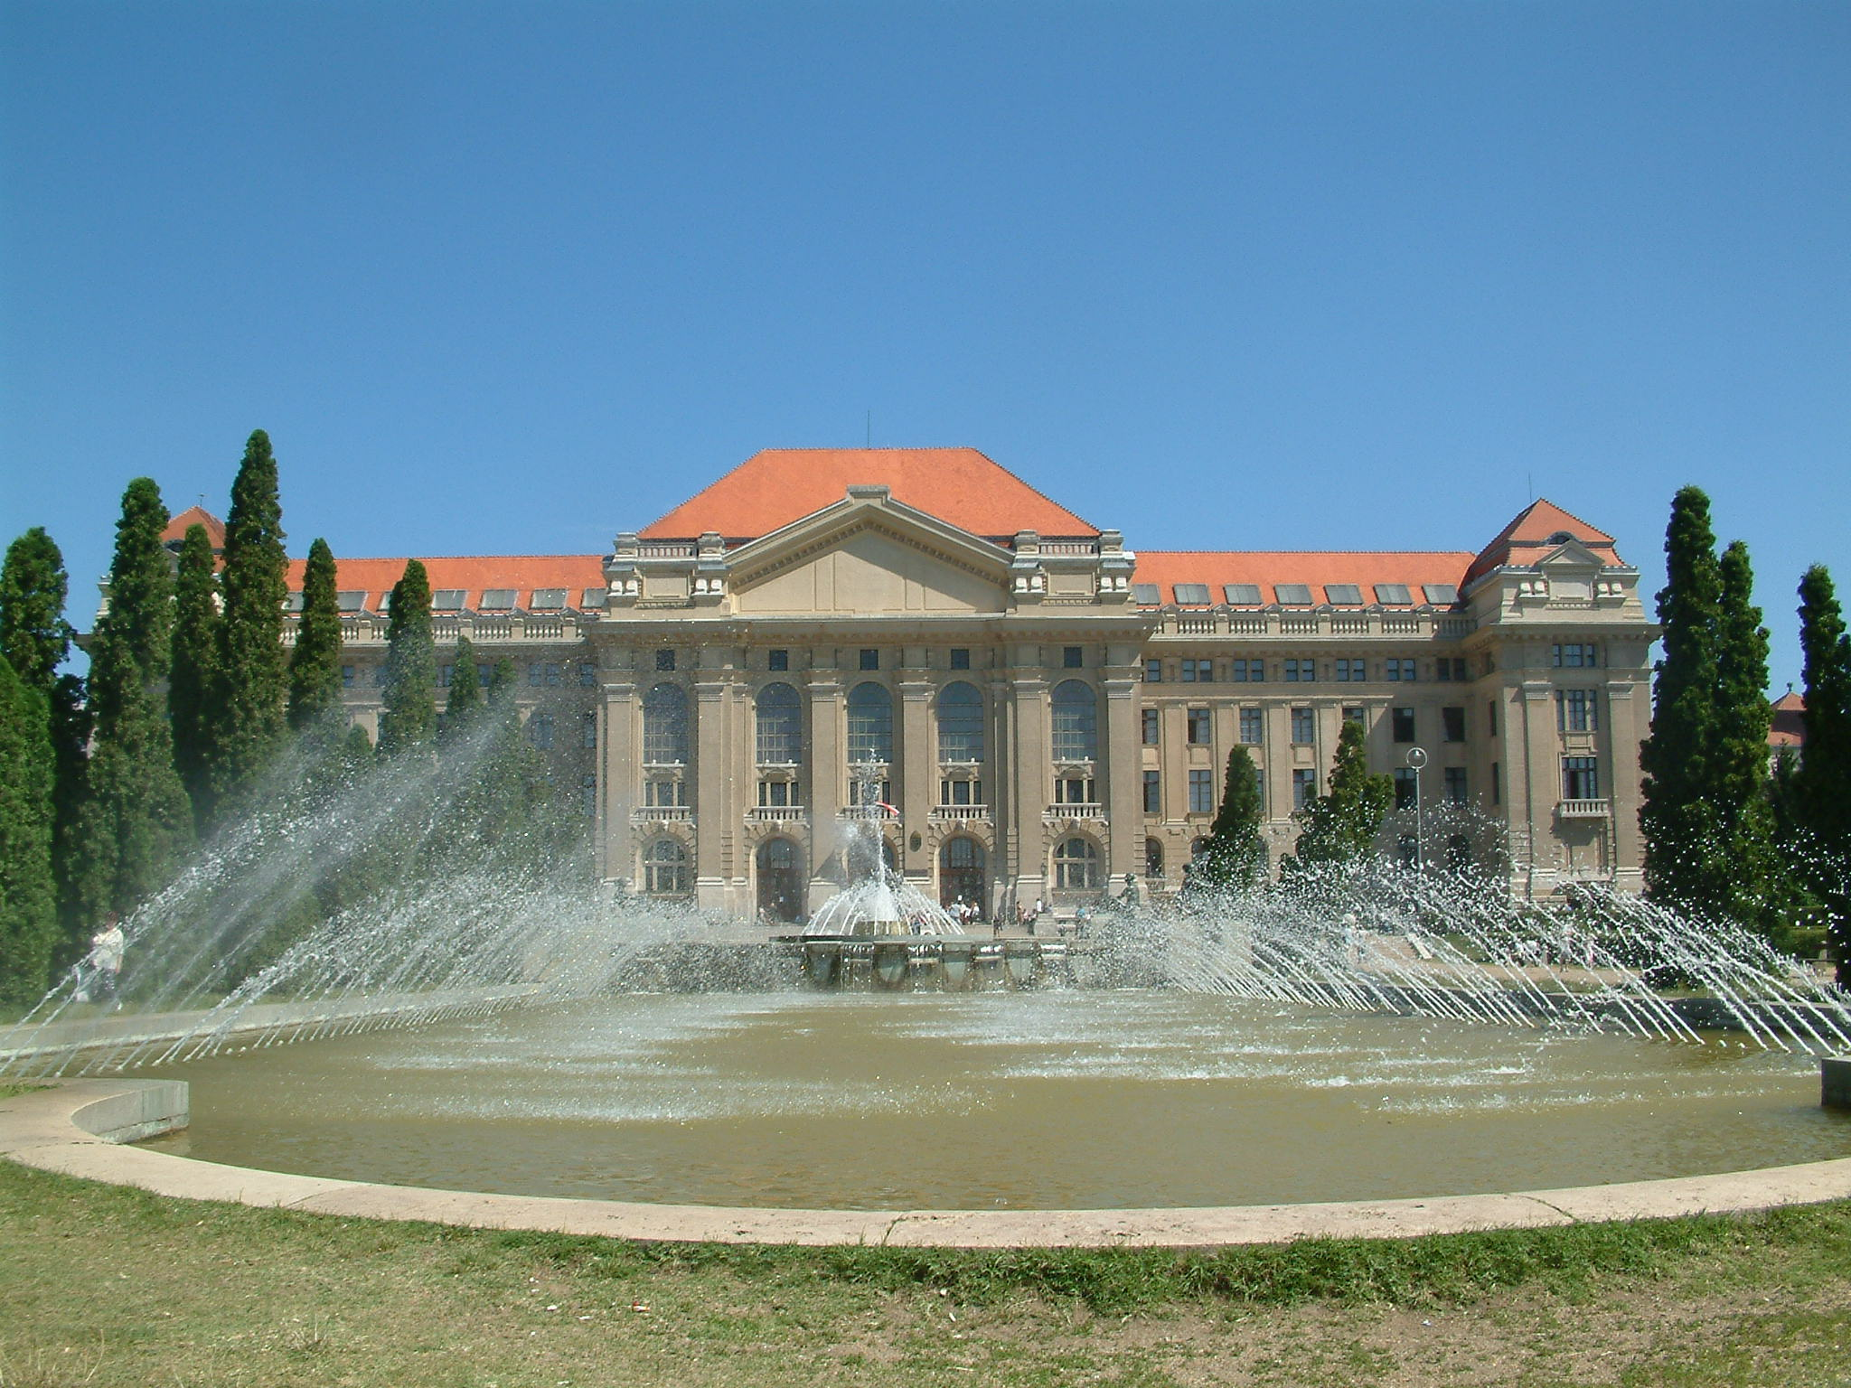

3rd Annual Meeting
Debrecen, Hungary
12-14 January, 2007

Program

The posters will be presented during the whole duration of the meeting.

January 12, Friday

18:00-19:00 General informations (Ferenc Joó, Maurizzio Peruzzini and Luca Gonsalvi)
19:00- RECEPTION (Poster session)

January 13, Saturday
Oral presentations:

Morning Session 1 (Chairman: Ferenc Joó)

8:00-8:40 Florence
Maurizio Peruzzini: Summary of the Aquachem activities of the Firenze group
- Ines Mallqui, Luca Gonsalvi, Maurizio Peruzzini, Antonio Romerosa, Manuel Serrano: Ru(II) complexes of water soluble phosphines dppEts and PTA for applications in aqueous phase catalysis

8:40-9:20 Toulouse
- Anne-Marie Caminade, Paul Servin, Mar Tristany, Régis Laurent, Jean-Pierre Majoral: Strategies for an attempted solubilization of dendritic organometallic complexes in water
- Paul Servin, Mar Tristany, Cyrille Rebout, Régis Laurent, Anne-Marie Caminade, Jean-Pierre Majoral: The birth of a super dense dendrimer and some new dendrimer ligands for catalysis
- Mar Tristany, Paul Servin, Régis Laurent, Anne-Marie Caminade, Jean-Pierre Majoral: Towards water-soluble dendrimer-based catalysts

9:20-10:00 Toulouse
- Agnès Labande, Joffrey Wolf, Eric Manoury, Jean-Claude Daran and Rinaldo Poli: Bifunctional ligands with N-Heterocyclic carbenes: synthesis, applications and potential in transition metal (aqueous) catalysis
- Chiara Dinoi, Rinaldo Poli, Luca Gonsalvi, Maurizio Peruzzini, Petr Prikhodchenko, Jenny Gun, Ovadia Lev: Mononuclear and Binuclear Cyclopentadienyl Oxo Molybdenum and Tungsten Complexes: Syntheses and Application in Olefin Epoxidation and Thiophene Oxidation Catalyses

10:00-10:40 York
- Robin N. Perutz, Anne-K. Duhme-Klair, Nicole Reddig, Kate Ronayne and Michael Towrie: Selective Oxometalate Sensors In Water/DMF Solvents
- Naseralla A. Jasim, Robin N. Perutz and Adrian C. Whitwood: Fluoropyridine modification can reverse the selectivity of Pt(PR₃)₂ for C-H over C-F bonds and stabilise a Pt-F complex

10:40-11:10 Coffee break (Poster session)

Morning Session 2 (Chairman: Maurizio Peruzzini)

11:10-11:50 Almería
- Antonio Romerosa, Sonia Mañas, Chaker Lidrissi, Manuel Serrano Ruiz: Water soluble ruthenium complex containing mPTA (mPTA=N-methyl-1,3,5-triaza-7-phosphaadamantane): Coordinative and photocemical properties
- Emma Petersen, Manuel Serrano, Chiara Ciardi and Antonio Romerosa: New water soluble phosphine ligands containing amino-acid groups.

11:50-12:30 Lisbon
- Luísa M. D. R. S. Martins: Chemistry in Aqueous Medium at the IST Group: an Overall View
- E. Alegria, L. Martins, A. Pombeiro: Water-soluble Scorpionates of Rhenium and Iron
- R. Wanke, E. Alegria, P. Servin, P. Smolenski, L. Martins, A-M. Caminade, A. Pombeiro: Synthesis and Reactions of Scorpionates: coordination to Fe and coupling with a dendrimer
K. Grunwald: Preliminary studies towards Co and Cu complexes with O-functionalized amines

12:30-13:10 Erlangen
- Joo-eun Jee, Alexander Theodoridis, Maria Wolak, Alicja Franke, Natalya Hessenauer and Rudi van Eldik: From NO to peroxide activation by model iron(III) complexes
- Małgorzata Brindell, Grażyna Stochel and Rudi van Eldik: Catalytic aspects of the reduction of (ImH)[trans-RuCl₄(dmso)(Im)] by ascorbic acid

13:10-14:30 Lunch (Poster session)

Afternoon Session (Chairman: Rinaldo Poli)

14:30-15:10 Moscow
- E. Shubina, O. Filippov, N. Belkova, V. Levina, E. Gutsul and L. Epstein: Solvent effect on the proton transfer process to and from metal-hydrides

15:10-15:50 Barcelona
Agustí Lledós: Summary of the Aquachem activities of the UAB (Barcelona) group
- G. Kovács, G. Ujaque, A. Lledós, F. Joó: Theoretical investigation of the stereoselective reduction of diphenylacetylene in aqueous acidic solutions catalyzed by water soluble ruthenium(II) phosphine complexes
- Aleix Comas-Vives, Joo-Eun Jee, Chiara Dinoi, Gregori Ujaque, Agustí Lledós, Rudi van Eldik, Rinaldo Poli: The Cp*MoO₂⁺ Complex in Water and the Solvent Role in the Intramolecular Proton Transfer Mechanism: A Theoretical Study.

15:50-16:30 Jerusalem
Ovadia Lev: Summary of the Aquachem activities of the Hebrew University of Jerusalem Group
- Peter Prikhodchenko: Electrooxidation of Ruthenium Cyclopentadienyl PTA Complexes in DMF: ESI-MS, Cyclic Voltammetry and On-Line electrochemistry/ ESI-MS studies.
- Andrey Charnyadev: Transformations of molybdenum species in highly in sulfidic solutions.
- Ovadia Lev: A mathematical model for a radial flow electrochemical cell for coupled ESI/MS studies

16:30-17:10 Debrecen
- Ferenc Joó: Recent results at the University of Debrecen, Hungary in the field of aqueous organometallic catalysis
- Almássy Ambroz: Water soluble N-heterocyclic carbene complexes of transition metals

17:10-17:50 General discussion (Poster session)
18:00 Bus leaves for Tuba-tanya
19:00 Dinner
22:30 (approx.) Return to Hotel

Posters:

P1. Ricardo R. Fernandes, Marina V. Kirillova, J. A. L. da Silva, João J. R. Fraústo da Silva, Armando J. L. Pombeiro: An iron (IV) complex as a catalyst for the oxidation of cyclohexane
P2. Joo-Eun Jee and Rudi van Eldik: Comparative mechanistic studies on the interaction of NO with highly charged Fe^{III} porphyrins and their nitrite-catalyzed reductive nitrosylation
P3. Yauhen Yu. Karabach, Alexander M. Kirillov, M. Fátima C. Guedes Da Silva, Matti Haukka, Maximilian N. Kopylovich, Armando J. L. Pombeiro: Synthesis and Characterization of Copper(II)-Aminopolyalcohol-Benzenepolycarboxylate Coordination Polymers
P4. Alexander M. Kirillov, Piotr Smolenski, M. Fátima C. Guedes da Silva, Armando J. L. Pombeiro: The First Copper Complexes Bearing the 1,3,5-triaza-7-phosphaadamantane (tpa) Ligand
P5. Telma F. S. Silva, Luísa M. D. R. S. Martins and Armando J. L. Pombeiro: Tris(1-pyrazolyl)methanesulfonate Vanadium(IV) Complex, a Water-Soluble Catalyst for Oxidation of Alkanes
P6. Antal Udvardy and Ágnes Kathó: Hydrogenation of sorbic acid catalyzed by Rh- and Ru-phosphine complexes
P7. Zhao Guo Ying , Joó Ferenc: Capture and Activation of Carbon Dioxide by Task-Specified Ionic Liquid

This meeting was sponsored by the University of Debrecen
and the Hungarian Academy of Siences



Oral presentations
1. Ru(II) complexes of water soluble phosphines dppEts and PTA for applications in aqueous phase catalysis

Ines Mallqui,ª Luca Gonsalvi,ª Maurizio Peruzzini,ª Antonio Romerosa,^{b} Manuel Serrano ^{b}

ª ICCOM CNR, Via Madonna del Piano 10, 50019 Sesto Fiorentino (Italy)
^{b} Area de Quimica Inorganica, Universidad de Almería, 04071, Almería (Spain)
e-mail: mmalqui@ual.es

The replacement of present catalytic technology with “greener” protocols using water as solvent is still a matter of research interest for both academia and industry. In this field, the cage-like water soluble monodentate phosphine 1,3,5-triaza-7-phosphaadamantane (PTA) has received renewed interest in the recent literature due to its properties to solubilize transition metal complexes in aqueous phase.
In the past few year we have investigated many aspect of this class of ligands, from the donor capacities of the potentially multidentate triaza phosphaadamantane moiety, resulting for example in the stable water soluble heterobimetallic coordination polymer [{CpRu(pta)₂(dmso-κS)}{AgCl₂}] or in the borane adduct PTA-BH₃, to the study of their coordination chemistry to Ru(II),,, Re(V), Rh(I) and Rh(III), mainly bearing cyclopentadienyl coligands.
We report here the latest results on the synthesis and the characterization of a family of water soluble metal complexes of formula [Ru{Cp(CONC(CH₃)₃)₂}(X)LL’]^{n} (Cp^{d} =; X = halogen, allenylidene ligands; L= PPh₃, PTA, mPTA, mTPPMS; L’ = PTA, mPTA, mTPPMS) (mPTA = methyl-1,3,5-triaza-7-phosphaadamantane). The aminoacid groups bonded to the Cp ring provide interesting electronic and steric properties to the complexes as well as better water solubility.
A second class of complexes subject of our studies is represented by the general formula [Ru(dppEts)(NN)Cl₂] (dppEts = 1,2-(bis[di-m-sodiumsulfato]-phenylphosphino)ethane; NN = (chiral) diamine) for applications in Noyori-type hydrogenations. Preliminary results on the synthesis and characterisation of these complexes will be described.

2. STRATEGIES FOR AN ATTEMPTED SOLUBILIZATION OF DENDRITIC ORGANOMETALLIC COMPLEXES IN WATER

Anne-Marie CAMINADE, Paul SERVIN, Mar TRISTANY, Régis LAURENT,
Jean-Pierre MAJORAL

Laboratoire de Chimie de Coordination du CNRS, 205 route de Narbonne, 31077 Toulouse Cedex 4, France. E-mail: caminade@lcc-toulouse.fr

Dendrimers constitute undoubtedly the most original type of macromolecular architectures drawn up in the last two decades in the field of special polymers; they induce an increasing interest, with more than 1000 publications and more than 120 patents per year since 4 years. Their unique multibranched and regular shape elaborated step-by-step (generation after generation) allows a perfect tuning of their chemical composition and size. Dendritic organometallic complexes constitute one of the main areas of research in the field of dendrimers, due to their potential catalytic properties.
We synthesize since twelve years dendrimers and various dendritic architectures possessing one phosphorus atom at each branching point, and our main present interest concerns their use in various fields such as materials, biology and catalysis. In particular, we have already shown that organometallic derivatives of these phosphorus-containing dendrimers may act as catalysts for various reactions in organic solvents, but all these compounds are insoluble in water. However, the synthesis of water-soluble dendritic catalysts appears highly desirable, due to their potential recovery and reuse. Indeed, such compounds should meet the requirement for a sustainable development both by avoiding the use of organic solvents and the waste of metals and catalysts. We have already synthesized water-soluble dendrimers to study their biological properties, by introducing positive or negative charges as end groups. The main challenge to obtain water-soluble dendritic catalysts consists in having in a single dendritic structure both organometallic derivatives, and charges. This can be theoretically achieved by several ways shown in the following scheme: the organometallic complexes can themselves bear charges (case a); both complexes and charges can be linked to each branching point of the surface (case b); complexes can be located on one side of the surface and charges on the other side (case c), and this can be done in various proportions (case d); or the complexes can be inside the structure, and the charges on the surface (case e). An overview of these various types of structures will be given.
3. The birth of a Super Dense Dendrimer and
some new Dendrimer ligands for Catalysis

Paul SERVIN, Mar TRISTANY, Cyrille REBOUT, Régis LAURENT, Anne-Marie CAMINADE, Jean-Pierre MAJORAL

Laboratoire de Chimie de Coordination du CNRS, 205 route de Narbonne, 31077 Toulouse Cedex 4, France. E-mail: servin@lcc-toulouse.fr

The most commonly utilized synthesis of phosphorus dendrimers (see figure 1) starts with the reaction of a core with a spacer (4-hydroxybenzaldehyde). Afterwards the first generation is created by a condensation reaction with phosphorhydrazide. By this methodology the dendrimer only grows every second reaction. With the Super Dense Dendrimer (see figure 1) every reaction creates a new branching point and therefore a new generation. This is done by utilizing 5-hydroxy isophthaldehyde instead of 4-hydroxybenzaldehyde. The Super Dense Dendrimer can unfortunately only be synthesized up to generation four due to steric hindrance and branch entanglement. Hopefully this new dendrimer can be used in any application where high density might improve the result and in particular in catalysis where the local high metal density on the surface should give an improved “dendritic” effect.
Figure 1. Four reaction steps with Super Dense Dendrimer to the left and common phosphorus dendrimer to the right.

Some new ligands for catalysis have been prepared individually and in co-operation both with Portugal and Spain. In the co-operation with Portugal we finally managed to graft a scorpionate derivative on the surface of a first generation dendrimer. The PNP-ligand was some time ago a hot topic in Spain and in our co-operation two PNP-ligands were synthesized, one which has already been placed on different dendrimer generations.

Figure 2. Various synthesized ligands for catalysis.

4. TOWARDS WATER-SOLUBLE DENDRIMER-BASED CATALYSTS

Mar TRISTANY, Paul SERVIN, Régis LAURENT, Anne-Marie CAMINADE, Jean-Pierre MAJORAL

Laboratoire de Chimie de Coordination du CNRS, 205 route de Narbonne, 31077 Toulouse Cedex 4, France. e-mail: m_tristany@yahoo.fr

Dendrimers are hyperbranched (tree-like), perfectly defined (very low polydispersity), and bowl-shaped polymers, synthesized by the repetition of a sequence of reactions, which ensures the increase of both the size and the number of end groups generally located on the surface. The properties of dendrimers are mainly driven by the type of end groups they bear. One of the most interesting applications is in the field of catalysis when organometallic functional groups are grafted on the surface of dendrimers. Furthermore, it becomes more interesting if charged groups are also grafted, ensuring water-solubility to the macromolecule, and opening the door to its application on green chemistry.
Phosphorous-containing dendrimers with hexachloro-cyclotriphosphazene core are synthesized by the repetition of two reactions: the substitution of chlorine atoms by 4-hydroxybenzaldehyde, and the condensation between aldehyde functions and H₂N-N(Me)P(S)Cl₂. This dendritic architecture allows the grafting of both the catalyst and the water-soluble function to achieve water-soluble dendrimer-based catalysts. The group giving catalytic properties is based on an iminophosphine complex of palladium (M in the figure) and the group ensuring solubility in water on ammonium groups (+ in the figure). Three different approaches to this target had been proposed and will be presented: a) the respectively alternation of both end groups everywhere in the surface by chlorine monosubstitution reactions, b) the asymmetric growing of the dendrimer, using one of the branches for the catalyst functions and the rest for the water-soluble group, c) and the connection of two different dendrimers bearing each one the different surface function.
5. Bifunctional ligands with N-Heterocyclic carbenes: synthesis, applications and potential in transition metal (aqueous) catalysis

Agnès Labande, Joffrey Wolf, Eric Manoury, Jean-Claude Daran and Rinaldo Poli

Laboratoire de Chimie de Coordination, CNRS UPR 8241, 205 route de Narbonne, 31077 Toulouse cedex 4. Tel : +33 5 61 33 3173 ; fax : +33 5 61 55 30 03 ; e-mail : agnes.labande@lcc-toulouse.fr

N-heterocyclic carbene ligands (NHCs) have proved very useful for transition metal catalysis. Among them, bidentate ligands bearing a NHC and a heteroatom are particularly attractive for catalytic applications. Indeed, the carbene moiety gives robustness and air/thermal stability to the resulting complexes, while the heteroatom can potentially leave the metal to give a vacant coordination site.
With this perspective in mind, we have designed several ligands bearing a NHC, linked either to a phosphine^{3a} or a thioether moiety. The coordination chemistry of these ligands has been studied with various metals (Ni, Pd, Rh, Ir, Ru...) and the resulting complexes have been tested in several catalytic reactions with success (C-C coupling, hydrosilylation of ketones, transfer hydrogenation).

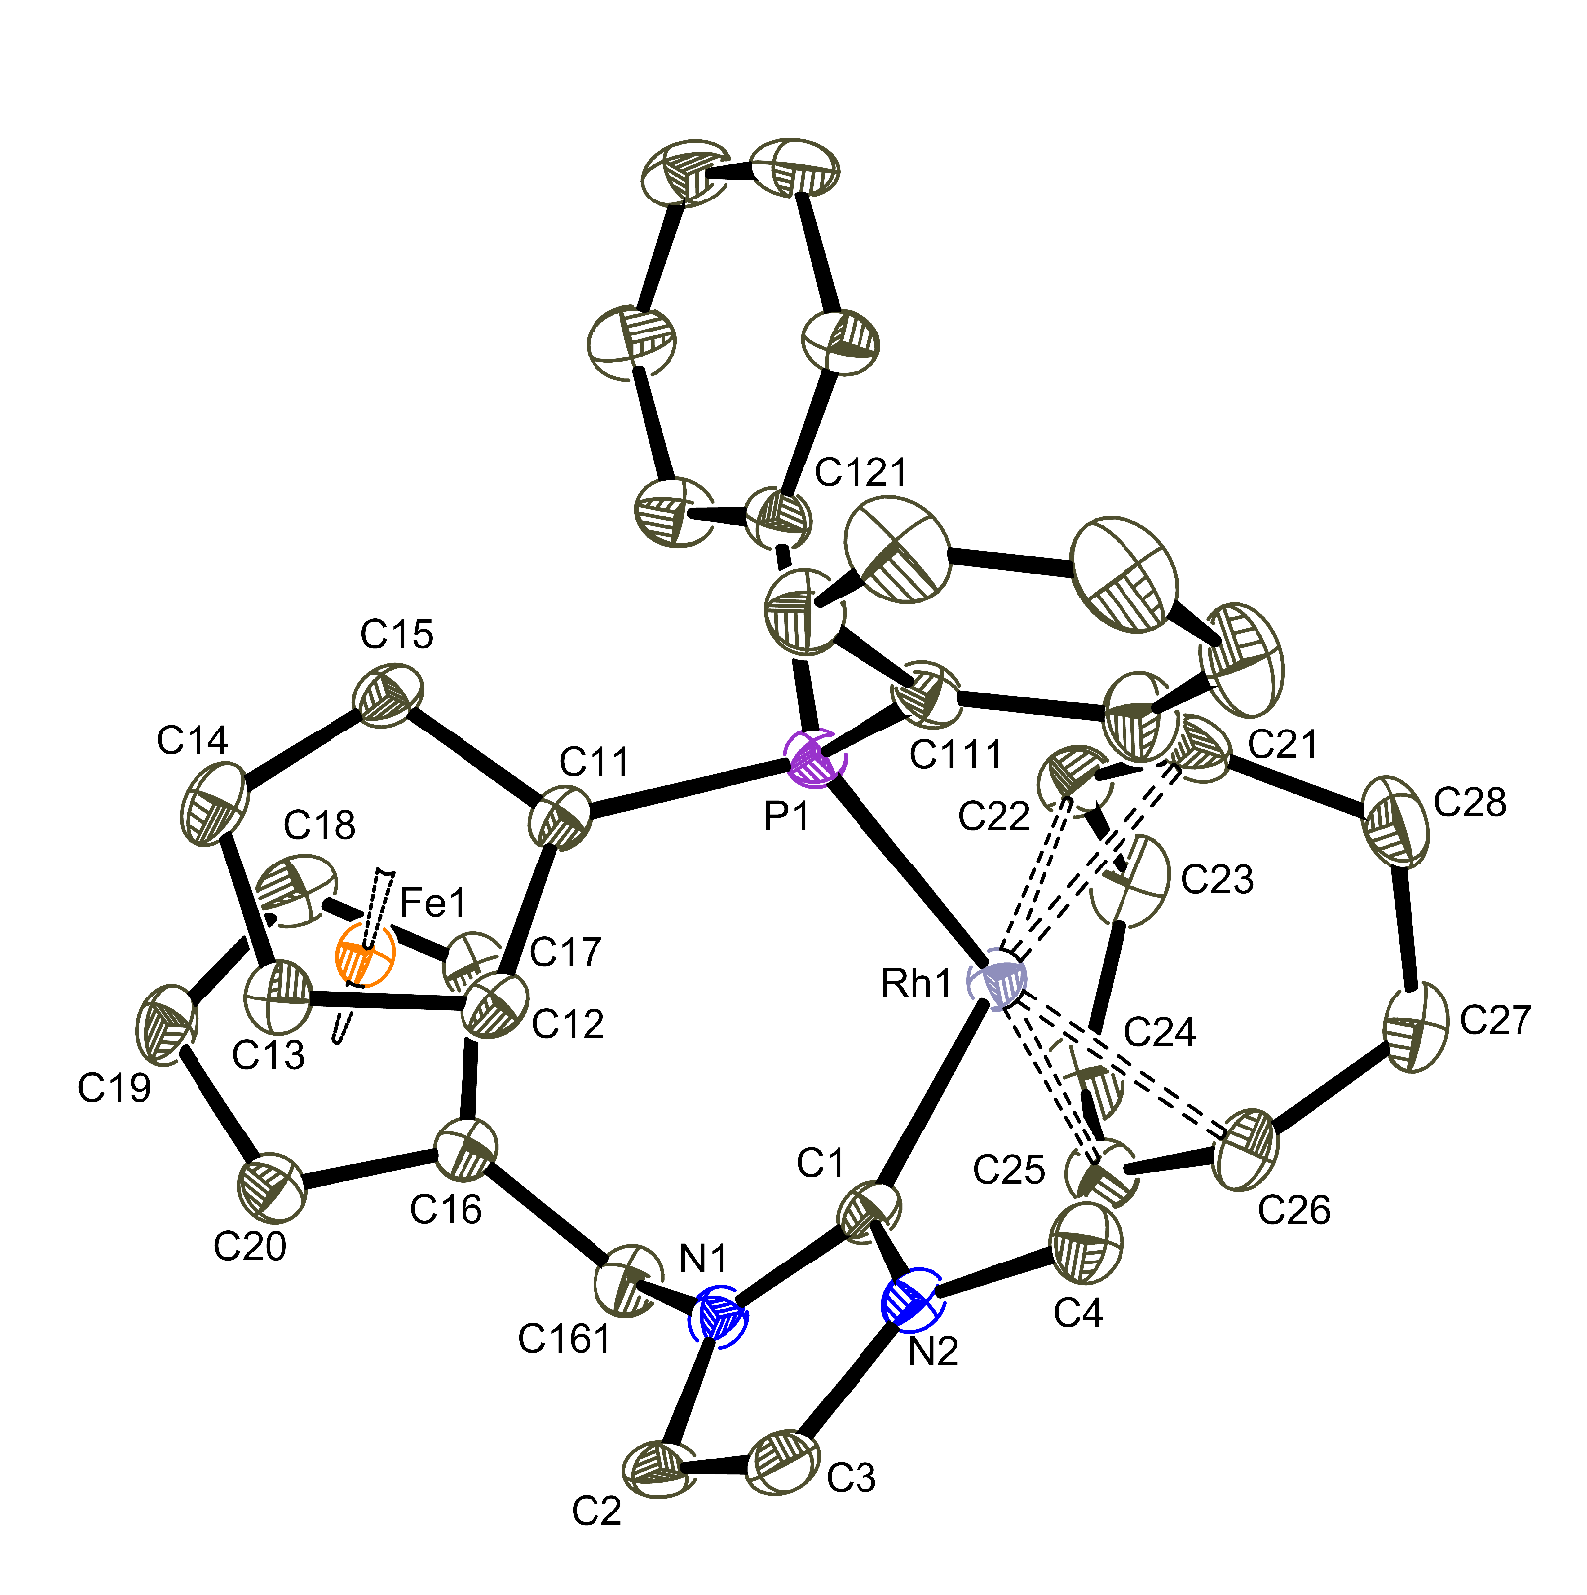 | 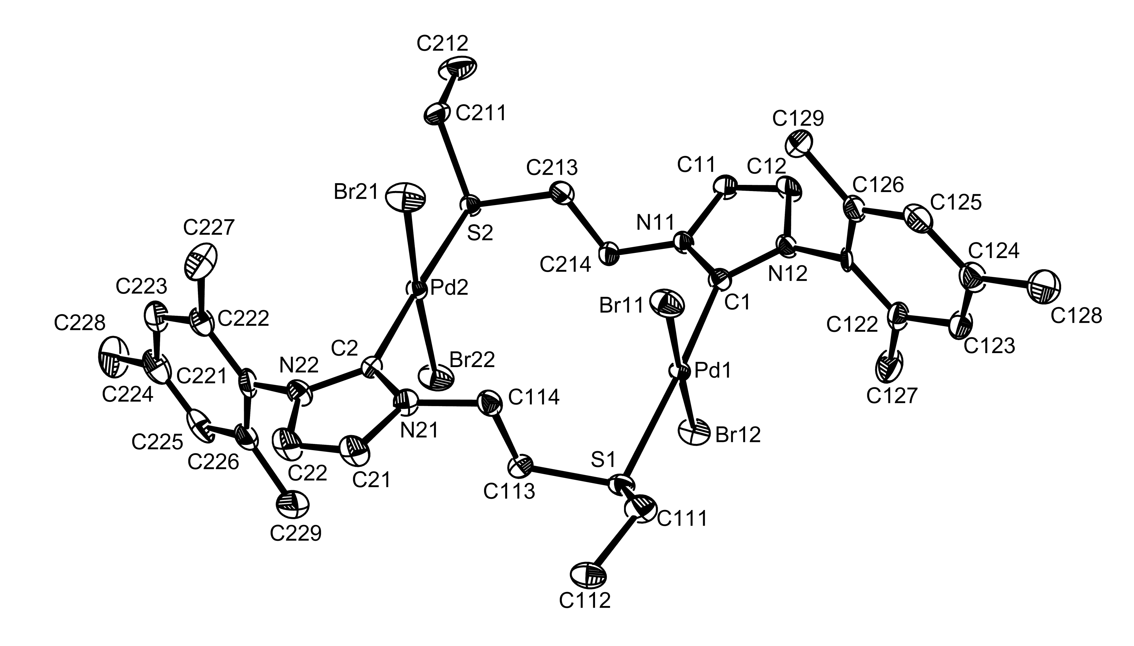

Our group is also very much concerned by the development of “green” processes in chemistry. Catalysis in aqueous media is a method of choice, which allows the synthesis of a wide range of valuable products in an environmentally friendly system. We now plan to apply the general synthetic methods to the preparation of hydrosoluble ligands, in order to study their potential for catalysis in water.

6. Mononuclear and Binuclear Cyclopentadienyl Oxo Molybdenum and Tungsten Complexes: Syntheses and Application in Olefin Epoxidation and Thiophene Oxidation Catalyses

Chiara Dinoi,¹ Rinaldo Poli, ¹ Luca Gonsalvi, ² Maurizio Peruzzini, ² Petr Prikhodchenko,³ Jenny Gun, ³ Ovadia Lev³

dinoi@lcc-toulouse.fr

¹Laboratoire de Chimie de Coordination du CNRS, 205 route de Narbonne, 31077 Toulouse Cedex, France – ²Istituto di Chimica dei Composti Organometallici (ICCOM-CNR), Via Madonna del piano 10, 50019 Sesto Fiorentino (FI), Italy –³Laboratory of Environmental Chemistry, Department of Chemistry, The Hebrew University of Jerusalem, Jerusalem, 91904 Israel.

High oxidation state organometallic compounds, mostly supported by oxo ligands, are now a well established family and exhibit remarkable catalytic activities in oxidation processes. Our group studies the chemistry of high oxidation state organometallic compounds with the long term goal of developing catalytic and electrocatalytic applications in water, the greenest available solvent. The preferred precursor has been the Cp*₂Mo₂O₅ complex, for which a high yield synthetic procedure has been recently developed in our laboratory.
While the previously reported best procedure involved the subsequent formation and isolation of the intermediates Cp*Mo(CO)₃Me and Cp*MoCl₄ from Cp*Mo(CO)₃⁻,¹ we have developed a one-pot conversion of the tricarbonyl anion to Cp*₂Mo₂O₅ without isolation of the Cp*MoO₃⁻ intermediate. Extension to the Cp*₂W₂O₅ analogue has also resulted in a significant improvement over the previous literature procedure.²
In a previous contribution,³ Cp’MoO₂Cl (Cp’ = C₅Bz₅, C₅H₅, C₅Me₅, C₅H^{i}Pr₄) and bimetallic [{MoCp’(O)₂}₂(μ-O)] (Cp’ = CpBz, Cp*, CpBut₃, CpPr^{i}₄) compounds were tested as olefin epoxidation catalysts, using cyclooctene as the substrate. All the above catalysts showed good catalytic activity with ^{t}BuOOH in organic solvent (CHCl₃). The Cp*₂Mo₂O₅ system was also investigated with aqueous ^{t}BuOOH and aqueous H₂O₂ as the oxidant. Catalytic activity was observed for the former system but not for the latter (either neutral or pH 1.5).
In order to better investigate the catalytic behaviour of the Cp*₂Mo₂O₅ complex in aqueous environments, we have re-examined this system, focusing our attention on the epoxidation of cyclooctene in a MeOH/H₂O mixture, with both ^{t}BuOOH and H₂O₂.
Finally, the bimetallic Cp*₂Mo₂O₅ compound was also tested as a catalyst precursor for thiophene oxidations: the activity for the oxidation of benzothiophene and dibenzothiophene by H₂O₂ in MeCN will be described.

[1] D. Saurenz, F. Demirhan, P. Richard, R. Poli, H. Sitzmann, Eur. J. Inorg. Chem. 2002, 1415-1424.
[2] M.S. Rau, C. M. Kretz, G. L Geoffroy, Organometallics, 1993, 12, 3447-3460.
[3] a) Mary K.Trost, Robert G.Bergman, Organometallics, 1991, 10, 1172-1178.
b) M. Abrantes, A.M. Santos, J. Mink, F.E. Kuhn, C.C. Romao, Organometallics, 2003, 22, 2112-2118.
c) A.M. Martins, C.C. Romao, M. Abrantes, M. C. Azevedo, J. Cui, A. R. Dias, M. T. Duarte, M. A. Lemos, T. Lourenco, R. Poli, Organometallics, 2005, 24, 2582-2589.
7. Selective Oxometalate Sensors In Water/DMF Solvents

Robin N. Perutz,ª Anne-K. Duhme-Klair,ª Nicole Reddig,ª Kate Ronayne^{b} and Michael Towrie^{b}

ª Department of Chemistry, University of York, York, YO10 5DD; ^{b}Central Laser Facility, CCLRC Rutherford Appleton Laboratory, Chilton, Didcot, Oxon., OX11 0QX

The development of luminescent sensors for the detection of oxoanions provides one of the most efficient means of selective analysis. Our studies address oxometalates since there are no selective chemosensors available for molybdate, tungstate or vanadate. We have recently reported a rhenium carbonyl bipyridine complex that acts as a molybdate sensor via luminescence quenching.[] The complex includes a catecholate binding unit capable of electron transfer to rhenium. The sensor molecules are designed to signal the presence of molybdate by a change in the emission intensity (Fig. 1). They are studied in water/dimethylformamide solvent mixtures containing 5 to 20% water.
Figure Left Structure of sensor molecule. Right Structure of 2:1 complex with molybdate
We have investigated the response of the sensor to pH with and without molybdate making use of steady state and time-resolved spectroscopy. The rhenium bound CO-ligands provide reporters for the investigation of the photophysical properties of the systems by time-resolved infrared (TRIR) spectroscopy. Almost complete quenching of luminescence is observed in the presence of molybdate down to pH values as low as 0.1. At low pH, the absorption and the TRIR spectra of the sensor are consistent with a metal-to-ligand (MLCT) excited state, typical of rhenium bipyridine complexes. A change in the spectra is observed both with pH and with molybdate binding that is consistent with catecholate-to-bipyridine charge transfer. This process is abbreviated as a ligand-to-ligand charge charge transfer (LLCT). An electron transfer process is observed on the picosecond timescale with a rate that is pH dependent. We show that this process converts the MLCT to a LLCT state.
We have isolated the red crystalline Mo:Re = 2:1 complex. The molecular structure of [MoO₂{Re(bpy)(CO)₃(L¹)}₂], determined by X-ray diffraction, shows two rhenium catecholamide units bound to the molybdate via chelating oxygen ligands from the catecholamide (Fig. 2). Electrospray mass spectrometric studies show that the same species is present in solution.

[] A. F. A. Peacock, H. D. Batey, C. Raendler, A. C. Whitwood, R. N. Perutz, A.-K. Duhme-Klair, Angew. Chem. Int. Ed. 2005, 44, 1712.
8. Fluoropyridine modification can reverse the selectivity of Pt(PR₃)₂ for C-H over C-F bonds and stabilise a Pt-F complex

Naseralla A. Jasim, Robin N. Perutz and Adrian C. Whitwood
Department of Chemistry University fo York, York, YO10 5DD, UK

Interest in carbon-fluorine activation by transition metals has been increasing with the discovery of several systems capable of activating C–F bonds.[] The metal-mediated synthesis of new fluoropyridines is based on the selective insertion of Ni(PEt₃)₂ into a C–F bond at the 2-position in pentafluoropyridine and related molecules. Recently, the focus has been on stoichiometric and catalytic derivatisation of fluoroaromatics via C-F activation at transition metal centres in the presence of a C–H bond. Here, we show that Pt(0) complexes react completely differently with fluoropyridines.
The reaction of Pt(PR₃)₂ (R = cyclohexyl, isopropyl) with 2,3,5,6-tetrafluoropyridine yields cis-[PtH(C₅F₄N)(PR₃)₂] in a C–H activation process; the cis isomer can be converted to the trans isomer by heating or photolysis. In contrast, reaction of pentafluoropyridine with Pt(PR₃)₂ at room temperature follows a more complex course involving P–C and C–F bond cleavage, and formation of P–F and P–C bonds. The products are complexes of the type trans-[Pt(R)(C₅F₄N)(PR₃)(PFR₂)] (Scheme).[] The mechanism requires initial C–F activation and formation of the platinum fluoride complex intermediate, which was not detected by NMR spectroscopy at low or room temperature.

Pt(PR₃)₂ is normally selective for C–H over C–F bonds, but the selectivity can be reversed with a CF₃ substituent. Modification of the fluoropyridine led to a platinum fluoride complex. The resultant platinum fluoride reacts with Et₃SiOTf to form the platinum H₂O complex hydrogen-bonded to a triflate ligand. Reaction of [Pt(F)(C₅F₂HNCF₃)(PR₃)₂] with NEt₃.3HF led to the elimination of the fluoropyridine ring and formation of a fluorine-bridged platinum dimer.

9. WATER SOLUBLE RUTHENIUM COMPLEX CONTAINING mPTA (mPTA=N-methyl-1,3,5-triaza-7-phosphaadamantane): COORDINATIVE AND PHOTOCHEMICAL PROPERTIES.

Antonio Romerosa, Sonia Mañas, Chaker Lidrissi, Manuel Serrano Ruiz.
Área de Química Inorgánica. Universidad de Almería, 04120, Almería. Spain. romerosa@ual.es.

Not many examples of water soluble catalysts have been so far described which is quite surprising in view of the intense research activity centred on hydrosoluble metal complexes and the pressing request for developing more and more environmentally benign technologies in manufacturing of fine chemicals.[1] We are working in this hot area of chemistry for several years and have demonstrated that: (i) ruthenium vinylidenes and allenylidenes stabilised by the water soluble phosphine mTPPMS (mTPPMS = m-sulphonatedtriphenylphosphine) efficiently catalyzes the ROMP of cyclic alkenes,[2] (ii) lead to the trans-etherification of vinil-ether,[3] (iii) the water soluble ruthenium complex [RuClCp(PTA)₂] (PTA = 1,3,5-triaza-7-phosphaadamantane) brings about the selective hydrogenation of benzylidene acetone in water,[4,5] (iv) the water soluble complexes [RuCp(L)(L’)X]^{n+} (X = Cl, I; L= PPh₃ and L’ = PTA, mPTA; L = L’ = PTA, mPTA) (mPTA = N-methyl-1,3,5-triaza-7-phosphaadamantane) have shown DNA activity.[6] As a further step forward in this area, we report here the synthesis and characterization of the new water soluble ruthenium complex [RuCl₂(mPTA)₄](CF₃SO₃)₄ (Figure) which reacts with small molecules (H₂O, etc.) depending on whether or not the substitution reaction is irradiated by solar light, displaying therefore this complex solar photochemical activity.
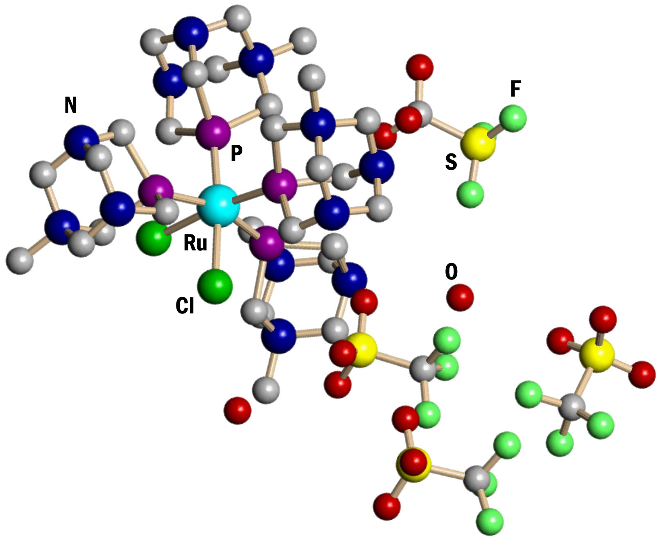

ACKNOWLEDGEMENTS: To MCYT (Spain) for CTQ2006-06552/BQU and PAI (Junta de Andalucía, FQM-317), also to EC for the MCRTN program AQUACHEM (contract MRTN-CT-2003-503864) and the COST Actions D17 and D29.

References: [1] R. H. Grubbs, in Aqueous Organometallic Chemistry and Catalysis, I. T. Horváth, F. Joó, Eds.; NATO ASI Ser. 3 5; Kluwer Academic Publishers, Dordrecht, The Netherlands, 1995, p. 15. [2] M. Saoud et al. Organometallics, 2000, 19, 4005-4007. [3] M. Saoud et al. E.J.I.C. 2003, 1614-1619. [4] S. Bolaño et al J. Mol Cat. 2004, 224, 61-70. [5] D. Akbayeva et al, Chem. Comm. 2003, 264-265. [6] A. Romerosa et al. Inorg. Chem. 2006, 45, 1289-1298

10. New water soluble phosphine ligands containing amino-acid groups.

Emma Petersen, Manuel Serrano, Chiara Ciardi and Antonio Romerosa.

Universidad de Almería, Área de Química de Inorgánica, 04071 Almería (Spain)
(email romerosa@ual.es)

Water as a solvent in organic synthesis is a new concept in chemistry that could provide a reduction of the cost of the synthetic processes by increasing the yield and reducing the subproducts obtained and therefore reducing environment impact. Most of the actual catalysts are designed to be soluble in organic solvents and those water soluble use to discompose by reaction with water. Even more there are not suitable water soluble catalysts for stereoselective synthesis which is mandatory for obtaining most of biologically active compounds.

We have designed an amine acid based phosphine which provide most of the adequate characteristic features for a ligand useful to obtain catalytic complexes that includes chiral centres which could induce steroselectivity. The amine acid groups including in the ligand contain at least two chiral centres. Also its special features like an acid group and amine group can enhance its stereoselectivity, in for instance drug design or synthesis of natural products.

In our research group we are preparing a group of amine acid based phosphines, in which one of the key steps is the formation of γ-amino-β-hydroxy phosphines., That kind of phosphine is made stereoselectively by reaction of a epoxide with a diphenyl borane complex. The next synthesis process step implicates removing the borane group that provides the free phosphine ligand useful to be used as a ligand.

11. Chemistry in Aqueous Medium at the IST Group:
an Overall View

Luísa M. D. R. S. Martins

Departamento de Engenharia Química, Instituto Superior de Engenharia de Lisboa, 1950-062 Lisboa, Portugal. Centro de Química Estrutural, Complexo I, Instituto Superior Técnico, 1049-001 Lisboa, Portugal. e-mail: lmartins@deq.isel.ipl.pt

During the third year of the AQUACHEM Project, the studies of the IST group were mainly directed towards the following areas:
- syntheses of metal complexes with water soluble phosphines, namely the first examples of copper complexes bearing tpa or any derived ligand with a cage-like tpa core, and Pt(II or IV) complexes;
- syntheses of iron complexes with the “N₂S₂” ligand and study of their catalytic activity in the peroxidative oxidation of cyclohexane;
- synthesis of copper(II)-aminopolyalcohol-benzenepolycarboxylate coordination polymers;
- application of water soluble mono-, di- and polynuclear copper complexes as catalysts for the peroxidative oxidation of alkanes under mild conditions;
- functionalization of hydrotris(1-pyrazolyl)methane providing different classes of new ligands;
- syntheses of metal complexes with water soluble scorpionate ligands and their application as catalysts for the oxidation of alkanes under mild conditions;
- study different applications of trispyrazolyl ligands in the chemistry of dendrimers;
- application of Pt-PTA and Re complexes in the Baeyer-Villiger oxidation reactions;
- electrochemical investigation of water soluble metal complexes.

These studies are outlined and their significance from synthetic, catalytic and biological viewpoints is discussed.

Acknowledgements

This work has been partially supported by the AQUACHEM Project RTN nº MRTN-CT-2003-503864, the IPL/41/2003 project, the POCI 2010 (FEDER funded) program and by the Fundação para a Ciência e Tecnologia (FCT), Portugal.

12. Water-soluble Scorpionates of Rhenium and Iron

E. Alegria^{a,b}, L. Martins^{a,b}, A. Pombeiroª

ª Centro de Química Estrutural, Complexo I, Instituto Superior Técnico, Av. Povisco Pais, 1049-001, Lisboa, Portugal.
^{b} Departamento de Engenharia Quimica, ISEL, R. Conselheiro Emídio Navarro, 1950-062, Lisboa, Portugal.

The coordination chemistry of “scorpionate” nitrogen donor ligands has been widely developed in the last years and their complexes have found applications in processes with biological and industrial significance.
We now report the reactions of HCpz₃ and Li[SO₃Cpz₃] with Re and Fe centres, leading to the first tris(pyrazolyl)methanesulfonate complexes of rhenium(V and VII) and iron(II) and to some hydrotris(pyrazolyl)methane complexes of these metals. In addition, an unsual acetone-pyrazolyl coupling led to a chelated pyrazolyl-alkoxide.^{1,2}
Their redox properties, studied by cyclic voltammetry, allowed to estimate, for the first time, the Lever electrochemical E_{L} parameter for the SO₃C(pz)₃⁻ and oxo ligands.

X = SO₃⁻, H

The catalytic activity of some complexes in the peroxidative oxidation of cyclohexane to the corresponding alcohol and ketone, under mild conditions, in aqueous medium and with an environmentally friendly oxidant is also reported.³

Acknowledgements: This work has been partially supported by the AQUACHEM Project RTN nº MRTN-CT-2003-503864, the IPL/41/2003 project, the POCI 2010 (FEDER funded) program and by the Fundação para a Ciência e Tecnologia (FCT), Portugal.

¹ E.C.B.A. Alegria, L.M.D.R.S. Martins, M.F.C.G. da Silva and A.J.L. Pombeiro, J. Organomet. Chem. 690, 2005, 1947.
² E.C.B. Alegria, L.M.D.R.S. Martins, M. Haukka and A.J.L. Pombeiro, J. Chem. Soc. Dalton Trans., 2006, 4954-4961.
³ E.C.B. Alegria, M.V. Kirillova, L.M.D.R.S. Martins and A.J.L. Pombeiro, Appl. Catal. A: General, 317, 2007, 43-52.

13. Synthesis and Reactions of Scorpionates:
coordination to Fe and coupling with a dendrimer

R. Wankeª, E. Alegria^{a,b}, P. Servin^{c}, P. Smolenskiª, L. Martins^{a,b},
A-M. Caminade^{c}, A. Pombeiroª

ªCentro de Química Estrutural, Complexo I, Instituto Superior Técnico, Av. Rovisco Pais, 1049-001, Lisboa, Portugal. ^{b}Departamento de Engenharia Química, ISEL, R. Conselheiro Emídio Navarro, 1950-062, Lisboa, Portugal. ^{c}Laboratoire de Chimie de Coordination du CNRS, 205 Route de Narbonne, 31077 Toulouse Cedex 4.

The coordination chemistry of tridentate nitrogen donor ligands has been quite developed in the last years namely due to the applications of their complexes in industrial and biological processes.¹ In pursuit of our interest on the coordination chemistry of the N₃ tripodal neutral hydrotris(1-pyrazolyl)methane (HCpz₃, Tpm) and its reactions with iron(II) centres,² we have been investigating some functionalization reactions of HCpz₃ and coordination and coupling reactions of such species. We now report the reactions of scorpionate iron(II) complexes, e.g., [FeCl₂(HCpz₃)] or [FeCl₂(SO₃Cpz₃)] with PTA (1,3,5-triaza-7-phosphaadamantane) or derivatives, which are water soluble phosphines. We also report the reactions of FeCl₂·2H₂O with the above phosphines leading to complexes of type [FeCl₂(PTA)_{n}], that can further react with Tpm. Attempts to increase the water solubility of this type of complexes will also be discussed. Their synthesis and characterization by IR and multinuclear NMR spectroscopies, FAB⁺-MS spectrometry, elemental analysis and electrochemical methods are also presented.
With the cooperation of the Toulouse group, we have coupled HO-CH₂-Cpz₃ with G_{c1} dendrimer bearing –CH₂I on the surface. Other coupling approaches will be reported by P. Servin.

Acknowledgements: This work has been partially supported by the AQUACHEM Project RTN nº MRTN-CT-2003-503864, the IPL/41/2003 project, the POCI 2010 (FEDER funded) program and by the Fundação para a Ciência e Tecnologia (FCT), Portugal.

¹ (a) Pettinari, C.; Pettinari, R.; Coord. Chem. Rev. 2005, 249, 525. (b) Pettinari, C.; Satini, C.; Comprehensive Coordination Chemistry II, Vol. 1 (Ed. J. A. McCleverty, T. J. Meyer), Elsevier, Oxford, 2004, p.159.
² E. Alegria, R. Wanke, L. Martins, A. J. Pombeiro; Synthesis and electrochemical behaviour of Scorpionate Iron Complexes, ICOMC 2006, International Conference in Organometallic Chemistry, Zagaroza, Spain; 2006, P078, 266.
14. From NO to peroxide activation by model iron(III) complexes

Joo-eun Jee, Alexander Theodoridis, Maria Wolak, Alicja Franke, Natalya Hessenauer and Rudi van Eldik*

Institute for Inorganic Chemistry, University of Erlangen-Nürnberg, Egerlandstr. 1,
91058 Erlangen, Germany. e-mail: vaneldik@chemie.uni-erlangen.de

It is our goal to contribute towards the mechanistic understanding of the different reaction steps in the catalytic cycle of cytochrome P450 by employing model complexes and studying their behaviour in the presence of different oxidants and substrates. Of special interest is the activation of hydrogen peroxide, organic peroxides and peroxo acids by model Fe(III) complexes in the hydroxylation and epoxidation of various substrates following the peroxo-shunt pathway. Our work first focussed on the activation of NO by such Fe(III) complexes¹⁻⁶ from which we developed a good understanding of the underlying reaction mechanisms. On the basis of this understanding, we have now turned our attention to the activation of peroxides by model complexes for P450 and related porphyrin systems. The catalytic activity of these complexes was studied for different hydroxylation and epoxidation reactions using a variety of peroxides.⁷ Low-temperature rapid-scan techniques were employed, where possible, to characterize intermediates that participate in the catalytic cycle.⁸

1. A. Franke, G. Stochel, N. Suzuki, T. Higuchi, K. Okuzono and R. van Eldik, J. Am. Chem. Soc. 127, 5360-5375 (2005).
2. M. Wolak and R. van Eldik, J. Am. Chem. Soc. 127, 13312-13315 (2005).
3. J.-E. Jee, S. Eigler, F. Hampel, N. Jux, M. Wolak, A. Zahl, G. Stochel and R. van Eldik, Inorg. Chem. 44, 7717-7731 (2005).
4. J.-E. Jee, M. Wolak, D. Balbinot, N. Jux, A. Zahl and R. van Eldik, Inorg. Chem. 45, 1326-1337 (2006).
5. J.-E. Jee and R. van Eldik, Inorg. Chem. 45, 6523-6537 (2006).
6. A. Franke, N. Hessenauer-Ilicheva, D. Meyer, G. Stochel, W.-D. Woggon and R. van Eldik, J. Am. Chem. Soc. 128, 13611-13624 (2006).
7. M. Wolak and R. van Eldik, Chem. Eur. J. in press.
8. N. Hessenauer-Ilicheva, A. Franke, D. Meyer, W.-D. Woggon and R. van Eldik, Angew. Chem. submitted.

15. Catalytic aspects of the reduction of (ImH)[trans-RuCl₄(dmso)(Im)] by ascorbic acid

Małgorzata Brindell,^{a,b} Grażyna Stochelª and Rudi van Eldik^{b}

ªDepartment of Inorganic Chemistry, Faculty of Chemistry, Jagiellonian University, Ingardena 3, 30-060 Krakow, Poland
^{b}Institute for Inorganic Chemistry, University of Erlangen-Nürnberg, Egerlandstrasse 1, 91058 Erlangen, Germany

A systematic study of the reduction of (ImH)[trans-RuCl₄(dmso)(Im)] (NAMI-A), a promising anti-metastasing agent entering Phase II clinical trials, by L-ascorbic acid is reported. The rapid reduction of trans-[Ru^{III}Cl₄(dmso)(Im)]– results in formation of trans-[Ru^{II}Cl₄(dmso)(Im)]– in acidic medium (pH = 5.0) and is followed by successive hydrolysis of the chloride ligands, which can not be suppressed even in the presence of a large excess of chloride ions. The reduction of NAMI-A strongly depends on pH and is accelerated by higher pH. Over the small pH range 4.9 – 5.1, the reaction is quite pH independent and the influence of temperature and pressure on the reaction could be studied at pH 5.0. On the basis of the reported activation parameters and other experimental data, it is suggested that the redox process follows an outer-sphere electron transfer mechanism. A small contribution from a parallel reaction ascribed to inner-sphere reduction of aqua derivatives of NAMI-A, was found to be favored by lower concentrations of the NAMI-A complex and higher temperature. In the absence of an excess of chloride ions, the reduction process is catalyzed by the Ru(II) products being formed. The reduction of NAMI-A is also catalyzed by Cu(II) ions and the apparent catalytic rate constant was found to be 8.2 × 10⁷ M^{–2} s⁻¹ at 25 °C.

16. Solvent effect on the proton transfer process to and from metal hydrides

E. Shubina, O. Filippov, N. Belkova, V. Levina, E. Gutsul, L. Epstein

Transition metal hydrides exhibit two modes of reactivity in proton transfer reactions showing either acid or base behavior depending on the substrates. It was shown that hydride ligand could be the proton accepting site in a hydrogen bonded complex MH…HX; this step can define the selectivity of process and the way of proton transfer, and it always precedes the formation of cationic dihydrogen complexes.^{[1]} On the other hand many transition metal hydrides are known to be strong acids.^{[2]} Cationic classical and non-classical hydrides was shown can act as proton donors in hydrogen bonded complexes with ionic and neutral organic bases.^{[3]} Solvent effects on the proton transfer via such complexes and on their stability will be discussed. In contrast to cationic hydrides the MH…B between the neutral transition metal hydrides CpM(CO)₃H and bases and between two neutral hydrides was found only recently.^{[4]} These hydrogen bonded complexes are found to be the intermediates of proton transfer to organic bases yielding the hydrogen bonded ion pairs [M]–…⁺[H-B]. The thermodynamic characteristics of two steps of proton transfer from CpM(CO)₃H to organic substrate were recently obtained.
The structures, interaction energies, vibration frequencies and electron density distributions were analyzed for starting hydrides, H-bonded adducts, transition states and ion pairs by means of theoretical calculations taking into account the solvent effect. Very shallow minimum was found for the MH…B hydrogen bonded adduct, whereas the proton transfer yielding hydrogen bonded ion pairs [M–…⁺H-B] is energetically much more favored. The above characteristics of all the species are found to depend on the solvent polarity as well as on the solvent coordination ability. The combination of spectral and theoretical studies opens the possibility to predict the solvent effect on the proton transfer equilibrium and to control the reaction pathway.

This work is supported by RFBR (n° 05-03-32415), the European Commission’s RTN Program AQUACHEM (n° MRTN-CT-2003-503864), Division of Chemistry and Material Science of RAS, Russian Federation President Grant (MK – 4327.2006.3) and INTAS YSF (06-1000014-5809)me.

1. Belkova, N. V.; Shubina, E.; Epstein, L. M. Acc. Chem. Res. 2005, 38, 624-631.
2. (a) Kristjánsdóttir, S.S.; Norton J.R. in Transition Metal Hydrides (Ed.: A. Dedieu), VCH, New York, 1992, pp. 309-357. (b) Abdur-Rashid, K.; Fong, T.P.; Greaves, B.; Gusev, D.G.; Hinman, J.G.; Landau, S.E.; Lough, A.J.; Morris, R.H. J. Am. Chem. Soc., 2000, 122, 9155-9171.
3. (a) Epstein, L. M.; Shubina, E. S.; Krylov, A. N.; Kreindlin, A. Z.; Rybinskaya, M. I. J. Organomet. Chem., 1993, 447, 277-280. (b) Peris, E.; Crabtree, R. H. J. Chem. Soc., Chem. Commun. 1995, 2179-2181.
4. Belkova, N. V.; Gutsul, E. I.; Filippov, O. A.; Levina, V. A.; Valyaev, D. A.; Epstein, L. M.; Lledos, A.; Shubina, E. S. J. Am. Chem Soc., 2006, 128, 3486-3487.

17. Theoretical investigation of the stereoselective reduction of diphenylacetylene in aqueous acidic solutions catalyzed by water soluble ruthenium(II) phosphine complexes

G. Kovács^{a,b,c}, G.Ujaqueª, A. Lledósª, F. Joó^{b,c}
ªDepartament de Química, Universitat Autònoma de Barcelona, 08193 Bellaterra (Barcelona) Spain
^{b}Institute of Physical Chemistry, University of Debrecen, Debrecen 10, H-4010 Hungary
^{c}Research Group of Homogeneous Catalysis, Hungarian Academy of Sciences, Debrecen 10, P.O. Box 7, H-4010 Hungary
e-mail: gabor@klingon.uab.cat

Aqueous and especially aqueous-organic biphasic systems have provided new prospects in organometallic catalysis, since one major problem of homogenous catalysis, that is, the separation of the catalyst from the products can be easily achieved. One of the most described family of water-soluble complexes catalyzing different hydrogenation reactions are rhodium and ruthenium complexes prepared with sulfonated aromatic phosphine ligands.
Recently we have published a series of papers, in which, we intended to describe aqueous phase organometallic catalytic processes involving such complexes by means of theoretical methods^{[1]}. As a continuation of the aforementioned works, in the present study, the mechanism of the hydrogenation of 1,2-diphenylacetylene is analyzed by means of theoretical methods, with the intention to explore the origin of the observed stereoselectivity.
It has been published by Joó and co-workers recently^{[2]} that diphenilacetylene was hydrogenated under mild conditions in aqueous-organic biphasic systems with [{RuCl₂(mtppms)₂}₂] as catalyst in the presence of mtppms ligands. In acidic solution the major product of the reaction was found to be Z-stilbene with only traces of the E-stereoisomer and only a slight overreduction to 1,2-diphenylethane was observed. Nevertheless, basic conditions favoured the formation of E-stilbene and the major product was 1,2-diphenylethane. These observations were explained by the distribution of the catalytically active hydride species that are present in the solution as a function of the pH.
In this work, theoretical (DFT) methods were applied to account for the observed stereoselectivity under acidic aqueous reaction conditions. [RuHCl(PH₃)₃] was applied as model for the spectroscopically detected [RuHCl(mtppms)₃] complexes. The calculations show that the hydrogenation proceeds by the participation of both the hydride ligand and the hydroxonium ions present in acidic solutions at reasonable concentration. Since it was already known that appropriate inclusion of the solvent environment in the calculations is required for obtaining reasonable energetics, thus small clusters of water molecules were applied for modelling proton transfer reactions between the solvent and the catalytic intermediates. The stereoselectivity was explained on the basis of the different energy profiles gained for the possible reaction pathways.

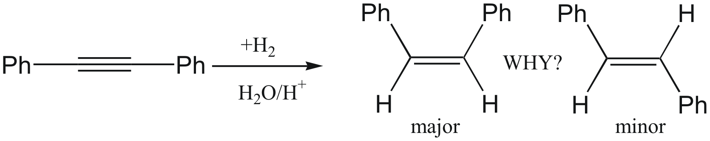

[1] a) Kovács, G.; Schubert, G.; Joó, F.; Pápai, I. Organometallics 2005, 24, 3059. b) Kovács, G.; Schubert, G.; Joó, F.; Pápai, I. Catal. Today 2006, 115, 53. c) Kovács, G.; Ujaque, G.; Lledós, A.; Joó, F. Organometallics 2006, 25, 862. d) Rossin, A.; Kovács, G.; Ujaque, G.; Lledós, A.; Joó, F. Organometallics 2006, 25, 5010.
[2] Horvath, H. H.; Joó, F. Reaction Kinetics and Catalysis Letters 2005, 85, 355.
18. The Cp*MoO₂⁺ Complex in Water and the Solvent Role in the Intramolecular Proton Transfer Mechanism: A Theoretical Study.

Aleix Comas-Vives,ª Joo-Eun Jee,^{b} Chiara Dinoi,^{c} Gregori Ujaque,ª Agustí Lledós,ª Rudi van Eldik,^{b} Rinaldo Poli^{c}
aleix@klingon.uab.cat

aUnitat de Química Física, Departament de Química, Edifici Cn, Universitat Autònoma de Barcelona, 08193 Bellaterra, Catalonia, Spain

bInstitute for Inorganic Chemistry, University of Erlangen-Nürnberg, Egerlandstr. 1, 91058 Erlangen, Germany

cLaboratoire de Chimie de Coordination, UPR CNRS 8241 liée par convention à l’Université Paul Sabatier et à l’Institut National Polytechnique de Toulouse, 205 Route de Narbonne, 31077 Toulouse Cedex, France

In the last two decades organometallic systems with metals in the highest oxidation states have been developed mainly devoted to perform efficient oxidation reactions. Their use has been usually confined to nonaqueous media, however, the use of water as solvent has attracted the attention of the organometallic community since it is a cheap, ecobenign and readily available solvent. In this line, the nature of the Cp*₂Mo₂O₅ complex has been studied in an aqueous media. The speciation of this complex is strongly dependent on the pH value. At pH < 2 the dominant species is Cp*MoO₂⁺ whether at pH > 6 the dominant species is Cp*MoO₃⁻.
We have recently studied in a joint experimental and theoretical work the nature of the Cp*MoO₂⁺ complex and the interconversion between the aquo and the dihydroxo complexes, Cp*MoO₂(H₂O)⁺ and Cp*MoO(OH)₂⁺, respectively. Rate constants and activation parameters have been determined experimentally.
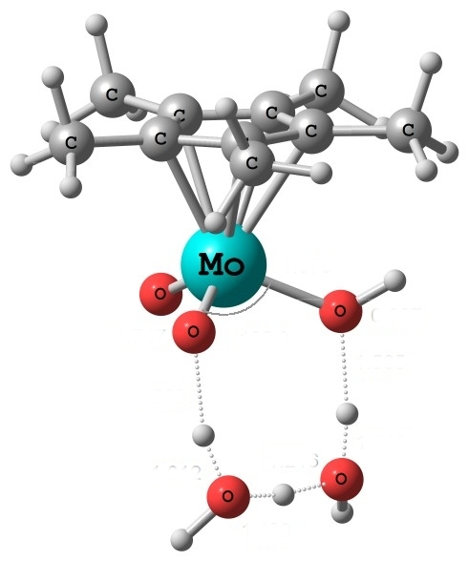
This talk will be focused on the computational results. In the calculations, a proper description of the solvent (modeled by CPCM and explicitly adding up to three water molecules) is crucial for lowering the energetic barrier for the interconversion between the aquo and the dihydroxo complexes.

19. Electrooxidation of Ruthenium Cyclopentadienyl PTA Complexes in DMF: ESI-MS, Cyclic Voltammetry and On-Line electrochemistry/ ESI-MS studies

Peter Prikhodchenko (Former ESR)

Halogen complexes of ruthenium cyclopentadienyl [CpRu(PTA)₂X]; [CpRu(PTA)(PPh₃)X]; [CpRu(PPh₃)₂Cl] and [RuCp(mPTA)(PPh₃)X]⁺ (Cp = C₅H₅; PTA = 1,3,5-triaza-7-phosphaadamantane; mPTA⁺ = [1-methyl-1,3,5-triaza-7-phosphaadamantane]⁺ ; X = Cl⁻, I⁻) were investigated by electrospray mass spectrometry (ESI-MS), in flow-cell cyclic voltammetry and by microelectrodes, and by combined, on-line electrochemistry and electrospray mass spectrometry (EC/ESI-MS) in DMF solution.
Coordination changes and the structures of the initial compounds and the products of the electrooxidation of the Ru(II) complexes were traced by in-situ EC/MS^{n} experiments which revealed their fragmentation pathways. The electrochemical studies show that it is possible to tune the formal potentials for the oxidation of [CpRuL₂X] complexes by over 300 mV by proper selection of the ligands. The increase of the redox potential by the different ligands follows the order PTA < PPh₃ < mPTA⁺.
We demonstrate a similarity between the propensity of the ligand to fragment out in the gas phase and its relationship to the formal potential of the complex.
20. Transformations of molybdenum species in sulfide rich solutions

Andrey Chernyadev (ESR fellow)

Hydrogen sulfide and polysulfide ions are potent natural cleansing agents. The compounds are known for their ability to dehalogenate organic contaminants by nucleophilic substitution. However, little is known about the detoxification power of sulfido-metallic complexes. We present our initial studies pertaining to the nucleophilicity of tetrathio molybdate and related compounds (including MoS₉²⁻; MoS_{x}O_{y}²⁻ (where x+y =4)).
In General, the nucleophilicity of the molybdenum and sulfur species follow the following order MoS₉²⁻ > S₆²⁻- S₄²⁻ > MoS₄²⁻ > MoS₃O²⁻ > MoS₂O₂²⁻ > S₂O₃²⁻ > HS⁻.
The reaction pathway of tetrathio molybdate with several pesticides and fumigants is described. We demonstrate for the first time that tetrathio molybdate catalyzes the reaction between hydrogen sulfide and halogenated organic substances.

21. A mathematical model for a radial flow electrochemical cell for coupled ESI/MS studies

Ovadia Lev

A mathematical model describing convection diffusion in a radial electrochemical cell was developed. This cell is used for our routine EC/ESI-MS studies. We demonstrate that cell’s performance can be predicted over a wide parametric range by a simple mathematical expression which converges to the Levich equation under low – conversion conditions.
The theoretical predictions of the model were in agreement with the results of on–line electrochemistry - mass spectrometry studies of dimethylaminomethyl ferrocene.
22. Recent results at the University of Debrecen, Hungary in the field of aqueous organometallic catalysis

Ferenc Joó

Institute of Physical Chemistry, University of Debrecen and Research Group of Homogeneous Catalysis, Hungarian Academy of Sciences, Debrecen 10, P.O.Box 7, H-4010 Hungary

Recent studies of the UD team were focussed on the following topics (mtppms = meta-monosulfonated triphenylphosphine):

1. Synthesis and catalytic properties of water-soluble N-heterocyclic carbene complexes with Ru(II), Rh(I) and Ir(I) central ions
2. Theoretical investigations on the mechanisms of selective catalytic hydrogenations in aqueous systems
3. The use of task-specific ionic liquids in catalytic hydrogenation of carbon dioxide
4. Immobilization of water-soluble metal complex catalysts by ion exchange
5. Selective biphasic hydrogenations in aqueous-organic systems
6. Synthesis and catalytic studies of water-soluble Ru(II)-vinylidene and allenylidene complexes

The presentation will cover topics 1 (in part) and 4, while topics 1, 3 and 5 will be described in more detail in the talk of Ambroz Almassy (1), on the poster of Guoying Zhao (3) and on the poster of Antal Udvardy (5). Most of the computational studies (2) were carried out in collaboration with the research group of Prof. Agustí Lledós, and some of the results will be presented by Gábor Kovács, now staying at UAB. Collaboration with Prof. A. Romerosa (U. Almería) has just recently started on topic 6.

Publications:
1. G. Kovács, G. Ujaque, A. Lledós, F. Joó: Theoretical investigation of the selective C=C hydrogenation of unsaturated aldehydes catalyzed by [{RuCl₂(mtppms)₂}₂] in acidic media. Organometallics 2006, 25, 862-872
2. A. Rossin, G. Kovács, G. Ujaque, A. Lledós, F. Joó: The Active role of the Water Solvent in the Regioselective C=O Hydrogenation of Unsaturated Aldehydes by [Ru(H)₂(mtppms)_{x}] in Basic Media. Organometallics 2006, 25, 5010-5023
3. G. Kovács, G. Schubert, F. Joó, I. Pápai: Theoretical investigation of catalytic HCO₃⁻ hydrogenation in aqueous solutions. Catalysis Today 2006, 115, 53-60
4. H. H. Horváth, G. Papp, C. Csajági, F. Joó: Selective catalytic hydrogenations in a microfluidics-based high throughput flow reactor on ion-exchange supported transition metal complexes. A modular approach to the heterogenization of soluble complex catalysts. Catal. Commun. 2007, 8, 442-446
5. M. Fekete, F. Joó: Redox isomerization of allylic alcohols in aqueous-organic biphasic systems catalyzed by water-soluble Ru(II)-N-heterocyclic carbene complexes. Catal. Commun. 2006, 7, 783-786
6. P. Csabai, F. Joó, A. M. Trzeciak, J. J. Ziółkowski: Catalytic activity of a half-sandwich Ru(II)-N-hetrocyclic carbene complex in the oligomerization of alkynes. J. Organometal. Chem. 2006, 691, 3371-3376

In addition to the Marie Curie Research Training Network, financial support of the work was also provided by the Hungarian National Research Fund, OTKA T043365, both are gratefully acknowledged.

23. Water soluble N-heterocyclic carbene complexes of transition metals

Almássy Ambroz

Institute of Physical Chemistry, University of Debrecen and Research Group of Homogeneous Catalysis of the Hungarian Academy of Sciences P. O. Box 7, H-4010 Debrecen

N-heterocyclic carbene (NHC) complexes of transition metals were successfully used as catalysts in metathesis, coupling reactions, polymerizations, hydrogenations and hydroformylation reactions. NHC-ligands are derived mostly from imidazolium or triazolium compounds. Isolation and crystallization of some free carbenes was described. Complexes of NHC-ligands are characterized by increased stability comparing to corresponding phosphine complexes. Water soluble NHC-complexes of Ag and Pd were also prepared and characterized.
The aim of our research is the preparation and characterization of water soluble NHC-complexes of transition metals and investigation of their catalytic activity. Required solubility would be achieved by introduction of polar groups (-SO₃H, -COOH) on the side chains attached on nitrogen atoms of imidazolium ring. Appropriate imidazolium precursors of carbene ligands were prepared by condensation of corresponding primary amines with glyoxal and paraformaldehyde. Activity of carbene complexes will be tested on hydrogenation and isomerization processes.

Posters

P1. AN IRON (IV) COMPLEX AS A CATALYST FOR THE OXIDATION OF CYCLOHEXANE

Ricardo R. FERNANDES, Marina V. KIRILLOVA, J. A. L. da SILVA,
João J. R. FRAÚSTO DA SILVA, Armando J. L. POMBEIRO

Centro de Química Estrutural, Complexo I, Instituto Superior Técnico, Av. Rovisco Pais, 1049-001 Lisbon, Portugal; e-mail: ricardofernandes@ist.utl.pt, pombeiro@ist.utl.pt

Functionalization of saturated hydrocarbons catalyzed by inorganic compounds is attracting much attention, since they are the main constituents of oil and natural gas, and potential primary industrial feedstocks.
In particular, the oxidation of such compounds (e.g. cyclohexane) under mild conditions, with non-toxic oxidants (molecular oxygen or hydrogen peroxide) is a challenge to modern chemistry.
A wide range of transition-metal species is known to be capable of catalyzing these organic oxidations, including biomimetic species which act as models for cytochromes P-450, methane monoxygenases and other enzymes. In this communication, we present the results obtained for a variety of studies on the catalytic activity of an high oxidation state iron complex [Fe^{IV}(“N₂S₂”)(PBu₃)] , or derived, in the peroxidative oxidation (by aqueous H₂O₂) of cyclohexane (scheme 1), under mild conditions, in acetonitrile.

Scheme 1

We have investigated the influence of different parameters such as the presence and type of co-catalyst (pyrazine-2-carboxylic acid, pyrazine-2,3-dicarboxylic acid, 3-aminopyrazine-2-carboxylic acid), amount of substrate, amount of oxidant, temperature, and achieved maximum yields and TONs of ca. 35% and 440, respectively. The catalyst, or its precursor, is efficient even in the absence of the co-catalyst, but the yields, in some cases, can increase dramatically in the presence of the co-catalyst.

This work has been partially supported by the Human Resources and Mobility Marie Curie Research Training Network (AQUACHEM project, CMTN-CT-2003-503864) and the Foundation for Science and Technology (FCT), and its POCI 2010 programme (FEDER funded).

P2. Comparative mechanistic studies on the interaction of NO with highly charged Fe^{III} porphyrins and their nitrite-catalyzed reductive nitrosylation

Joo-Eun Jee and Rudi van Eldik*
Institute for Inorganic Chemistry, University of Erlangen-Nürnberg, Egerlandstrasse 1, 91058 Erlangen, Germany. joo-eun.jee@chemie.uni-erlangen.de

The reactions of the water soluble iron(III) porphyrins, (P⁸⁺)Fe^{III [1]} bearing eight positively-charged meso substituents and (P⁸⁻)Fe^{III} ^{[2]} with eight negatively-charged meso substituents, with NO were studied as a function of pH, temperature and pressure to assess the influence of the highly charged meso substituents. The porphyrin complexes react with NO to yield the nitrosyl adducts, (P^{n})Fe^{II}(NO⁺)(L) (L = H₂O or OH⁻), (n = 8+, 8-). The diaqua-ligated porphyrins (P^{n})Fe^{III}(H₂O)₂ bind and release NO according to a dissociative mechanism analogous to that reported earlier for other (P)Fe^{III}(H₂O)₂ species.^{[3]} The nitrosyl complexes (P⁸⁻)Fe^{II}(H₂O)(NO⁺) and (P⁸⁺)Fe^{II}(H₂O)(NO⁺) undergo subsequent reductive nitrosylation reactions that were found to be catalyzed by nitrite, also produced during the reaction. On the basis of data obtained from temperature and pressure dependence measurement, mechanistic pathways for the studied reactions are proposed. The available results favor the operation of an inner-sphere electron transfer process between nitrite and coordinated NO⁺. The results obtained for (P⁸⁺)Fe^{III} and (P⁸⁻)Fe^{III} are compared with data reported for other water-soluble iron(III) porphyrins with positively- and negatively-charged meso substituents.^{[4]}
References:
[1] [5,10,15,20-tetrakis-(4’-t-butyl-2’,6’-bis(4-t-butylpyridine)-phenyl)porphinato]iron(III)
[2] [5⁴,10⁴,15⁴,20⁴-tetra-t-butyl-5²,5⁶,15²,15⁶-tetrakis-(2,2-bis-carboxylato-ethyl)-5,10,15,20-tetraphenylporphyrin] iron(III)
[3] (a) Jee, J-E, Balbinot, D.; Jux, N.; Zahl, A.; van Eldik, R. Inorg. Chem. 2006, 45, 1326 (b) Jee, J-E, Eigler, S.; Hampel, F.; Jux, N.; Wolak, M.; Zahl, A.; Stochel, G.; van Eldik, R. Inorg. Chem. 2005, 44, 7177. (c) Laverman, L. E.; Ford, P. C. J. Am. Chem. Soc. 2001, 123, 11614. (d) Wolak, M.; van Eldik, R. J. Am. Chem. Soc. 2005, 127, 1331
[4] (a) Jee, J-E.; van Eldik, R. Inorg. Chem. 2006, 45, 6523 (b) Fernandez, B. O.; Lorkobic, I. M.; Ford, P. C. Inorg. Chem. 2004, 43, 5393. (c) Theodoridis, A.; van Eldik, R. J. Mol. Catal. A. 2004, 224, 197.
P3. Synthesis and Characterization of Copper(II)-Aminopolyalcohol-Benzenepolycarboxylate Coordination Polymers

Yauhen Yu. Karabachª, Alexander M. Kirillovª, M. Fátima C. Guedes Da Silvaª, Matti Haukka^{b}, Maximilian N. Kopylovichª, Armando J. L. Pombeiroª

ª Centro de Química Estrutural, Complexo I, Instituto Superior Técnico, Av. Rovisco Pais, 1049–001 Lisbon, Portugal. E-mail: pombeiro@ist.utl.pt; ^{b} University of Joensuu, Department of Chemistry, P.O. Box 111, FIN-80101, Joensuu, Finland

The design of copper-organic polymeric molecules is an intensively growing research field in inorganic, coordination and supramolecular chemistries, which attracts particular attention due to the structural and practical characteristics of such materials such as their uncertain structural diversity and microporosity, interesting molecular sorption, ion exchange and catalytic properties, usually different from the related mononuclear species. Aromatic polycarboxylic acids along with aminopolyalcohols are known to be good building blocks in designing copper-organic polymeric materials with varying topologies.^{[1]}
The main task of the current work consists in extending the growing family of Cu coordination polymers by self-assembly synthesis of two novel compounds derived from reaction of copper(II) nitrate in water solution with either methyldiethanolamine (H₂mdea) or triethanolamine (H₃tea) as auxiliary ligands, and terephthalic or trimesic acids as spacers. The obtained compounds [Cu₂(Hmdea)₂(μ-H₂O){μ-C₆H₄(COO)₂-1,4}]_{n}∙2nH₂O (1) and [Cu₂(H₂tea)₂{μ-Na(H₂O)₂}{μ-C₆H₄(COO)₃-1,3,5}]_{n}∙6nH₂O (2) have been characterized by conventional methods including X-ray single crystal structural analyses (drawings). The latter reveal the formation of intercalated branched polynuclear chains of water clusters in 2.

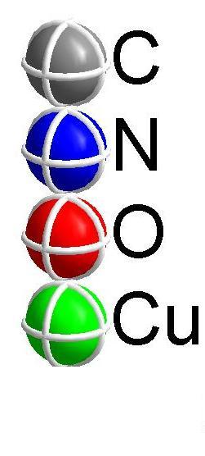  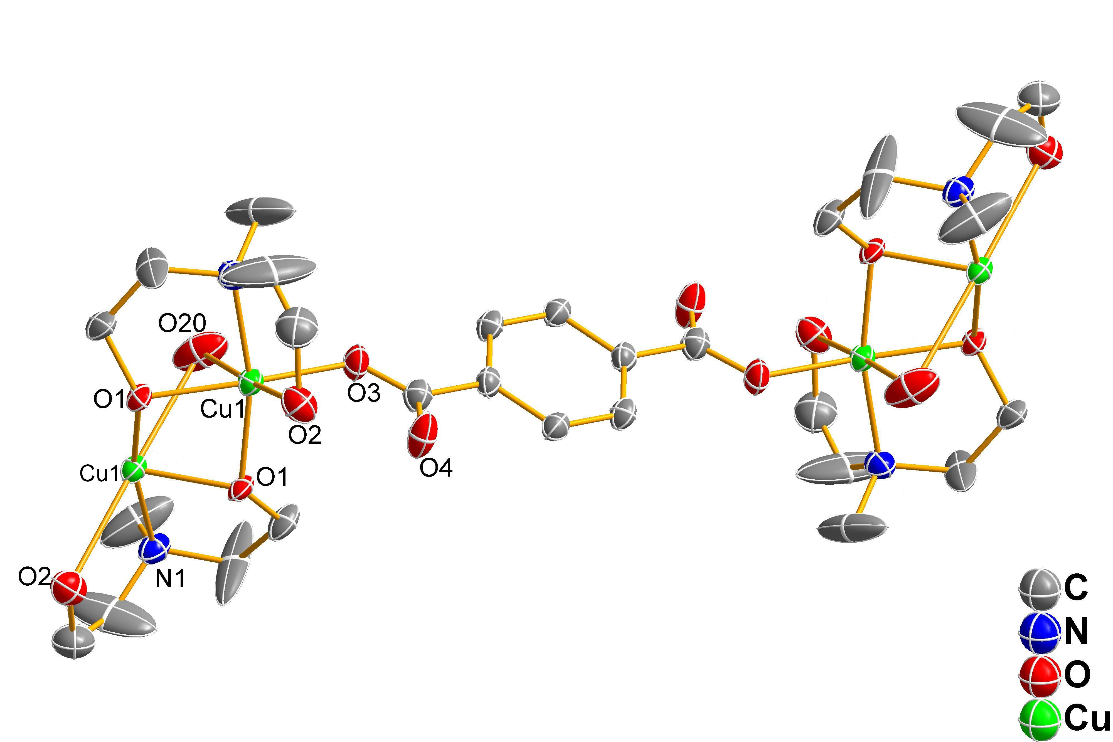  1 | 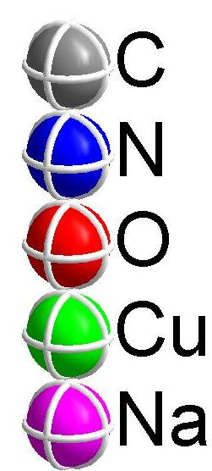  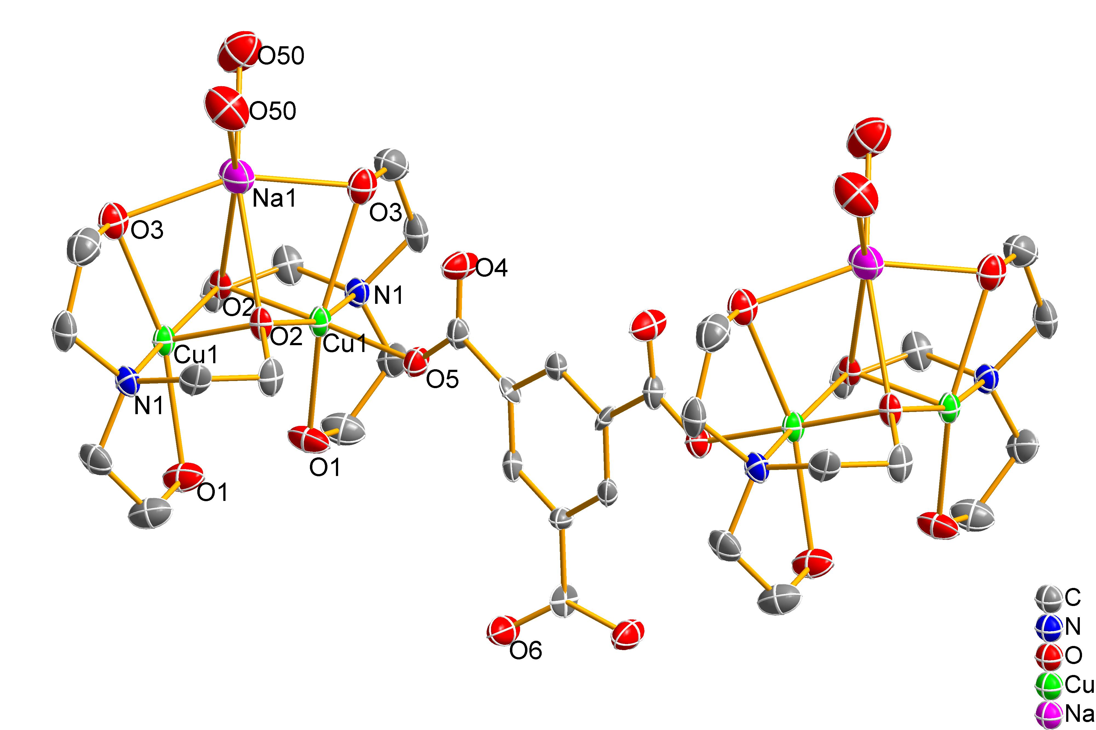  2

Preliminary catalytic activity tests of 1 and 2 for the mild peroxidative oxidation of cycloalkanes to the corresponding cyclic alcohols and ketones reveal their good catalytic activity.
Acknowledgments: This work was supported by the FCT, its POCI 2010 programme (FEDER funded) and by the MCRTN (Aquachem project).

^{[1]} A. M. Kirillov, M. N. Kopylovich, M. V. Kirillova, M. Haukka, M. F. C. G. da Silva, A. J. L. Pombeiro, Angew. Chem. Int. Ed. 2005, 44, 4345; Ya. Yu. Karabach, A. M. Kirillov, M. F. C. G. da Silva, M. N. Kopylovich, A. J. L. Pombeiro, Cryst. Growth Des. 2006, 6, 2200.

P4. The First Copper Complexes Bearing the
1,3,5-triaza-7-phosphaadamantane (tpa) Ligand

Alexander M. Kirillov, Piotr Smolenski, M. Fátima C. Guedes da Silva, Armando J. L. Pombeiro

Centro de Química Estrutural, Complexo I, Instituto Superior Técnico, Av. Rovisco Pais,
1049–001 Lisbon, Portugal. E-mail: kirillov@ist.utl.pt, pombeiro@ist.utl.pt

The coordination chemistry of the aqua-soluble phosphine 1,3,5-triaza-7-phosphaadamantane (tpa) and derived species has received an increased interest in recent years,^{[1]} what is mainly due to the good solubility of transition metal tpa complexes in water, thus making possible their efficient applications in various areas. However, although a large variety of copper phosphine complexes has been reported, known water-soluble examples remain rather scant. Moreover, the Cu-tpa chemistry is virtually unknown^{[1]} and there were no examples, before the current report, of isolated copper complexes with tpa or its derivatives.
Hence, and by extending to the tpa chemistry our recent studies on water-soluble Cu complexes with N,O-ligands (which catalyze the mild functionalization of alkanes),^{[2]} we now report the easy synthesis of the new water-soluble Cu^{I} compounds [Cu(Htpa)₄](NO₃)₅ (1) and [Cu(tpa)₄](NO₃) (2) which constitute, as far as we are aware of, the first isolated examples of copper complexes bearing tpa or any derived ligand with a cage-like tpa core. They have been characterized by IR, ¹H, ¹³C{¹H}, ³¹P{¹H} and ⁶³Cu NMR spectroscopies, FAB⁺-MS, elemental and single crystal X-ray diffraction structural analyses. The latter show a nearly regular tetrahedral coordination environment about each copper centre filled by the P atoms of the four Htpa/tpa moieties, which show distinct and unusual geometrical arrangements if seen along the P−Cu bonds. The ³¹P{¹H} and ⁶³Cu NMR spectra of 2 in D₂O solution show spin coupling between the ³¹P and ⁶³Cu nuclei at room temperature.
The study also shows that it is possible to prepare, in a convenient way, Cu complexes bearing tpa (or its protonated form) ligands, allowing the expansion of the still limited group of water-soluble copper phosphine complexes, what encourages the search for their possible applications in aqueous media. The extension of the work towards the synthesis of Cu compounds with N-alkylated tpa derivatives as well as the catalytic activity tests of Cu-tpa species in aqueous medium are currently in progress.

This work was supported by the FCT, its POCI 2010 programme, and by the MCRTN (Aquachem project)
.
- For recent review, see: A. D. Phillips, L. Gonsalvi, A. Romerosa, F. Vizza, M. Peruzzini, Coord. Chem. Rev. 2004, 248, 955, and references therein.
- a) A. M. Kirillov, M. N. Kopylovich, M. V. Kirillova, E. Y. Karabach, M. Haukka, M. F. C. G. da Silva, A. J. L. Pombeiro, Adv. Synth. Catal. 2006, 348, 159; b) A. M. Kirillov, M. N. Kopylovich, M. V. Kirillova, M. Haukka, M. F. C. G. da Silva, A. J. L. Pombeiro, Angew. Chem. Int. Ed. 2005, 44, 4345; c) Y. Y. Karabach, A. M. Kirillov, M. F. C. G. da Silva, M. N. Kopylovich, A. J. L. Pombeiro, Cryst. Growth Des. 2006, 6, 2200.

P5. Tris(1-pyrazolyl)methanesulfonate Vanadium(IV) Complex, a Water-Soluble Catalyst for Oxidation of Alkanes

Telma F. S. Silva^{1,3}, Luísa M. D. R. S. Martins^{2,3} and Armando J. L. Pombeiro³

¹Área Científica de Física, Instituto Superior de Engenharia de Lisboa, Lisbon,Portugal.
²Departamento de Engenharia Química, Instituto Superior de Engenharia de Lisboa, Lisbon,Portugal.
³Centro de Química Estrutural, Instituto Superior Técnico, Lisbon,Portugal.
email: tsilva@dem.isel.ipl.pt

In the attempt to develop new processes for a more sustainable chemistry, we have been able to synthesise a V(IV) complex with the tris(1-pyrazolyl)methanesulfonate ligand, [VCl₃{SO₃C(pz)₃}], which is water-soluble and acts as a catalyst, or catalyst precursor, under mild conditions, in the peroxidative oxidation of cyclohexane (eq. 1) or cyclopentane (eq. 2) into their corresponding alcohols and ketones in aqueous/acetonitrile medium; as well as in the oxidation of methane or ethane to acetic and/or propionic acid, in a single-pot process, in the presence of the peroxodisulfate salt K₂S₂O₈ as the oxidizing agent and in trifluoroacetic acid as the solvent (eqs. 3 and 4).

Reaction conditions, turnover numbers and yields are reported.

Acknowledgements

This work has been partially supported by the AQUACHEM Project RTN nº MRTN-CT-2003-503864, the IPL/41/2003 project, the POCTI (FEDER funded) program and by the Fundação para a Ciência e Tecnologia (FCT), Portugal.
P6. Hydrogenation of sorbic acid catalyzed by
Rh- and Ru-phosphine complexes

Antal Udvardy and Ágnes Kathó
Institute of Physical Chemistry, University of Debrecen and Research Group of Homogeneous Catalysis of the Hungarian Academy of Sciences P. O. Box 7, H-4010 Debrecen

For the industrial synthesis of fine chemicals such as pharmaceuticals, vitamins and fragrances, unsaturated acids are useful starting materials. They can be obtained by the selective hydrogenation of α,β-unsaturated compounds.
The regioselective hydrogenation of 3,8-nonadienoic acid to 8-noneoic acid was realized in a benzene/water biphase with [RhCl(PPh₃)₃] as catalyst at 1 atm hydrogen whereas in the absence of water the reaction mostly gave 3-nonenoic acid [1].
One of our chief aim was to investigate whether this phenomena can be observed in the case of acids containing conjugated double bounds. Hydrogenation of sorbic acid (2,4-hexadienoic acid) catalyzed by Wilkinson’s compound led to the formation of hexanoic and 2-hexenoic acids in comparable amounts. By the addition of water to the solution the overall yields of the hydrogenated products were decreased, and mainly hexanoic acid was formed.
Almost identical conversion and selectivity values have been measured when potassium sorbate was hydrogenated in water in the presence of [RhCl(mtppms)]₃ (mtppms = monosulphonated-triphenylphopshine). The reaction was much faster, and more selective with respect to 2-hexenoic acid, if sorbic acid dissolved in organic solvent was hydrogenated in the presence of aqueous solution of [RhCl(mtppms)₃].
The effects of several parameters (e.g. temperature, hydrogen pressure, catalyst concentration) were studied both in homogeneous solutions and in water-organic biphasic systems, as well.
It was demonstrated that the other water soluble Rh- and Ru-complexes slowly catalyzed the hydrogenation of sorbic acid, and the selectivity to 2-hexenoic acid was also lower.

Acknowledgement: This work was supported by the AQUACHEM RTN-CT-2003-503864 and OTKA T043365.

[1] T. Okano, M. Kaji, S. Isotani, J. Kiji: Tetr. Lett., 33, 5547-5550 (1992)

P7. Capture and Activation of Carbon Dioxide
by Task-Specified Ionic Liquid

Zhao Guo Yingª , Joó Ferenc^{a,b}

a Institute of Physical Chemistry, University of Debrecen, P.O. Box 7, Debrecen H-4010, Hungary
b Research Group on Homogeneous Catalysis, Hungarian Academy of Sciences, P.O. Box 7, Debrecen H-4010, Hungary
fjoo@delfin.unideb.hu
Ionic liquids are well-known and excellent medium for metallic catalysis reaction. Also non-volatile task-specific ionic liquid(TSIL) provide a more clean way to capture the Carbon dioxide emission from power system and industry than traditional technology, which usually use amine –water solution as sequestration medium. TSIL with high concentrated CO2, which result from TSIL capture technology, will promote activation of CO2. Thus the integration of capture and transformation of carbon dioxide (for example hydrogenation, polymerization and so on )become possible because of TSIL, which is a interesting topic in view of clean technology and sustain development of economy. Herein we described the recent results we have obtained, including the synthesis of several TSIL and hydrogenation of CO2 to formic acid with TSIL in ionic liquid-water solution or ionic liquid water biphase, shown in the following figure. According to the initial results, the IL01 and IL02 is promising medium for hydrogenation of Carbon dioxide.
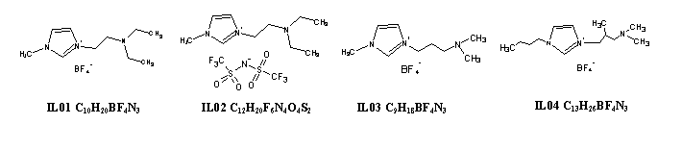

List of participants

Florence, ICCOM Prof. Maurizio Peruzzini mperuzzini@iccom.cnr.it
Italy Dr. Luca Gonsalvi l.gonsalvi@iccom.cnr.it
Ms. Ines Mallqui mmalqui@ual.es

Toulouse, LCC Prof. Rinaldo Poli poli@lcc-toulouse.fr
France Ms. Chiara Dinoi dinoi@lcc-toulouse.fr
Ms. Agnés Labande agnes.labande@lcc-toulouse.fr

Toulouse, LCC Prof. Anne-Marie Caminade caminade@lcc-toulouse.fr
France Dr. Paul Servin servin@lcc-toulouse.fr
Dr. Mar Tristany m_tristany@yahoo.fr

Erlangen, UEN Prof. Rudi van Eldik vaneldik@chemie.uni-erlangen.de
Germany Dr. Malgorzata Brindell brindell@anorganik.uni-erlangen.de
Ms. Joo-Eun Jee joo-eun.jee@chemie.uni-erlangen.de

Almería, UAL Prof. Antonio Romerosa romerosa@ual.es
Spain Dr. Emma Petersen petersenem@hotmail.com

Barcelona, UAB Prof. Agustí Lledós agusti@klingon.uab.cat
Spain Dr. Gregori Ujaque gregori.ujaque@uab.cat
Dr. Aleix Comas-Vives aleix@klingon.uab.cat
Dr. Gábor Kovács gabor@klingon.uab.cat

Lisboa, IST Dr. Elisabeth Alegría ebastos@deq.isel.ipl.pt
Portugal Dr. Luisa Martins lmartins@deq.isel.ipl.pt
Dr. Laurent Benisvy benisvy@yahoo.com
Ms. Telma Silva tsilva@dem.isel.ipl.pt
Ms. Katrin Grunwald katrin.gruenwald@gmail.com
Mr. Riccardo Wanke riccardowanke@mail.ist.utl.pt
Mr. Ricardo Fernandes ricardofernandes616@hotmail.com

Moscow, INEOS Dr. Elena Shubina shu@ineos.ac.ru
Russia Dr. Oleg Filippov h-bond@ineos.ac.ru

Jerusalem, HUJI Prof. Ovadia Lev ovadia@vms.huji.ac.il
Israel Mr. Ivan Ostapenko
Mr. Petr Prichodchenko prih@hotbox.ru
Mr. Andrey Chernadiev chernyadyev@mail.ru

York, YoK Prof. Robin Perutz rnp1@york.ac.uk
United Kingdom Dr. Naser Jasim

Debrecen, UD Prof. Ferenc Joó joofer49@yahoo.com
Hungary Dr. Guoying Zhao gz9@st-andrews.ac.uk
Dr. Ambroz Almassy almassy@fns.uniba.sk
Dr. Ágnes Kathó kathoagnes@yahoo.com
Ms. Marianna Fekete marijanafekete@yahoo.com
Ms. Henrietta H. Horváth h_hetti@freemail.hu
Mr. Gábor Papp combi1@yahoo.com
Mr. Antal Udvardy des99@freemail.hu
Ms. Csilla Nagy nagycsi@yahoo.com
Mr. István Győri
Mr. Péter Juhász m0qN9t@freemail.hu

Ms. Rugiada Girotti ru77@libero.it

A. D. Phillips, L. Gonsalvi, A. Romerosa, F. Vizza, M. Peruzzini, Coord. Chem. Rev. 2004, 248, 955.
C. Lidrissi, A. Romerosa, M. Saoud, M. Serrano-Ruiz, L. Gonsalvi, M. Peruzzini, Angew. Chem. Int. Ed. 2005, 44, 2568.
S. Bolaño, A. Albinati, J. Bravo, L. Gonsalvi and M. Peruzzini, Inorg. Chem. Comm. 2006, 9, 360.
D. N. Akbayeva, L. Gonsalvi, W. Oberhauser, M. Peruzzini, F. Vizza, P. Brüggeller, A. Romerosa, G. Sava. A. Bergamo, Chem. Commun. 2003, 264.
S. Bolaño, L. Gonsalvi, F. Zanobini, F. Vizza, V. Bertolasi, A. Romerosa, M. Peruzzini, J. Mol. Catal. A: Chem. 2004, 224, 61.
Romerosa, A.; Campos-Malpartida, T.; Lidrissi, C.; Saoud, M.; Serrano-Ruiz, M.; Peruzzini, M.; Garrido-Cardenas, J. A.; Garcia-Maroto, F., Inorg. Chem. 2006, 45, 1289.
S. Bolaño, L. Gonsalvi, P. Barbaro, A. Albinati, S. Rizzato, E. Gutsul, N. Belkova, L. Epstein, E. Shubina, M. Peruzzini, J. Organomet. Chem. 2006, 691, 629.
A. Dorcier, W. H. Ang, S. Bolaño, L. Gonsalvi, L. Juillerat-Jeannerat, G. Laurenczy, M. Peruzzini, A. D. Phillips, F. Zanobini, P. J. Dyson, Organometallics 2006, 25, 4090.
Launay N., Caminade A.M., Lahana R., Majoral J.P. Angew. Chem. Int. Ed. Engl. 1994, 33, 1589.
a) Servin P., Rebout C., Laurent R., Peruzzini M., Caminade A.M., Majoral J.P. Tetrahedron Lett. (in press). b) Maraval V., Laurent R., Donnadieu B., Mauzac M., Caminade A.M., Majoral J.P. J. Am. Chem. Soc. 2000, 122, 2499.
Majoral J.P., Caminade A.M. Chem. Rev. 1999, 99, 845.
Caminade A.M., Majoral J.P. Accounts Chem. Res. 2004, 37, 341.
Poupot M., Griffe L., Marchand P., Maraval A., Rolland O., Martinet L., L'Faqihi-Olive F.E., Turrin C.O., Caminade A.M., Fournié J.J., Majoral J.P., Poupot R. FASEB J. 2006, 2339.
a) Ouali A., Laurent R., Taillefer M., Caminade A.M., Majoral J.P. J. Am. Chem. Soc. (in press). b) Laurent R., Caminade A.M., Majoral J.P. Tetrahedron Lett. 2005, 46, 6503.
Majoral J.P., Caminade A.M., Maraval V., Chem. Commun., 2002, 2929
Servin P., Rebout C., Laurent R., Peruzzini M., Caminade A.M., Majoral J.P., Tetrahedron Lett. (in press).
Reger D.L., Grattan C.T., Brown K.J., Little C.A., Lamba J.J.S., Rheingold A.L., Sommer R.D., J. Organometallic Chem., 2000, 607, 120.
a) Bianchini C., Casares J.A., Peruzzini M., Romerosa A., Zanobini F., J. Am. Chem. Soc., 1996, 118, 4585. b) Bardaji M., Kustos M., Caminade A.M., Majoral J.P., Chaudret B., Organometallics, 1997, 16, 403.
a) Newkome, G.R. ; Vögtle, F. ; Moorefield, C.N. Dendrimers and Dendrons, Wiley-VCH, Weinheim, Germany, 2001. b) Fréchet, J. M.J. ; Tomalia, D.A. Dendrimers and Other Dendritic Polymers, John Wiley & Sons, Chichester, UK, 2001.
Majoral, J.P. ; Caminade, A.M.; Marvaral, V. Chem. Commun. 2002, 2929.
Launay, N. ; Caminade, A.M. ; Majoral, J.P. J. Organomet. Chem. 1997, 529, 51.
Koprowski, M.; Sebastián, R.M.; Maraval, V.; Zablocka, M.; Cadierno, V. ; Donnadieu, B.; Igau, A.; Caminade, A.M.; Majoral, J.P. Organometallics 2002, 21, 4680.
Loup, C. ; Zanta, M.A. ; Caminade, A.M. ; Majoral, J.P. ; Meunier, B. Chem. Eur. J. 1999, 5, 3644.
Lartigue, M.L. ; Slany, M. ; Caminade, A.M. ; Majoral, J.P. Chem. Eur. J. 1996, 2, 1417.
a) César et al., Chem. Eur. J. 2005, 11, 2862-2873. b) Ros et al., Organometallics 2006, 25, 6039-6046.
Bourissou et al., Chem. Rev. 2000, 100, 39.
a) J. Wolf, A. Labande, J.-C. Daran, R. Poli, J. Organometal. Chem. 2006, 691, 433.b) Wolf, J.; Labande, A.; Natella, M.; Daran, J.-C.; Poli, R. J. Mol. Cat. A 2006, 259, 205-212.
Li, C.-J. Chem. Rev. 2005, 105, 3095-3165.
[?] T. Braun and R. N. Perutz in Comprehensive Organometallic Chemistry III, Eds. Crabtree R H, Mingos D M P. Vol 1 Ch 26, Elsevier, 2006. T. Braun, R. N. Perutz, R. N. Chem. Commun. 2002, 2749. W. D. Jones, Dalton Trans. 2003, 3991. H. Torrens, Coord. Chem. Rev. 2005, 249, 1957.
[?]. N. A. Jasim R. N. Perutz, A. C. Whitwood, T. Braun, J. Izundu, B. Neumann, S. Rothfeld, and H.-G. Stammler, Organometallics, 2004, 23, 6140.
Muller, G., Sainz, D.J., Organometallic chem. ;1995, 495, 103
McNulty, J.; Zhou, Y., tetrahedron lett.; 2004, 45, 407
Collange, E.; Garcia, J. A.; Poli, R. New J. Chem. 2002, 26, 1249-1256.
Jee, J.-E.; Comas-Vives, A.; Dinoi, C.; Ujaque, G.; van Eldik, R.; Lledós, A.; Poli, R., submitted.
M. Scholl, T.M. Trnka, J.P. Morgan, R.H. Grubbs, Tetrahedron Lett. 1999, 40, 2247. J.A. Love, M.S. Sanford, M.W. Day, R.H. Grubbs, J. Am. Chem. Soc. 2003, 125, 10103.
A.C. Frisch, F. Rataboul, A. Zapf, M. Beller, J. Organomet. Chem. 2003, 687, 403. L. Ackermann, A. Furstner, T. Weskamp, F.J. Kohl, W.A. Herrmann, Tetrahedron Lett. 1999, 40, 4787. W.A. Herrmann, Angew. Chem. Int. Ed. 2002, 41, 1290.
M.G. Gardiner, W.A. Herrmann, C.-P. Reisinger, M. Spiegler, J. Organomet. Chem. 1999, 572, 239.
M.T. Powell, D.R. Hou, M.C. Perry, X. Cui, K. Burgess, J. Am. Chem. Soc. 2001, 123, 8878.
A.C. Chen, L. Ren, A. Decken, C.M. Crudden, Organometallics 2000, 19, 3459.
A.J. Arduengo III, R.L. Harlow, M. Kline, J. Am. Chem. Soc. 1991, 113, 361.
M. Scholl, S. Ding, C.W. Lee, R.H. Grubbs, Org. Lett. 1999, 1, 953.
L.J. Moore, S.M. Cooks, M.S. Anderson, H.-J. Schanz, S.T. Griffin, R.D. Rogers, M.C. Kirk, K.H. Shaughnessy, Organometallics 2006, 25, 5151.
Sellmann,D.; Emig, S.; Heinemann, F.W; Knoch, F.; Angew. Chem. Int. Ed. Engl. 1997, 36, 1201-1203.
P. J. Dyson, T. J. Geldbach, Springer, Heidelberg 2005, Metal Catalyzed Reactions in Ionic Liquids.
Zhang JM, Zhang SJ, Dong K, et al. Chem.-A Eur.J.,2006, 12 (15), 4021; Bates E.D., J. Am. Chem. Soc.,2002, 124, 926.
P.G. Jessop, C.-C. Tai, F. Joo, Coord. Chem. Rev.,2004,248,2425
I. Omae Catalysis Today,2006,115, 33.

