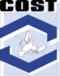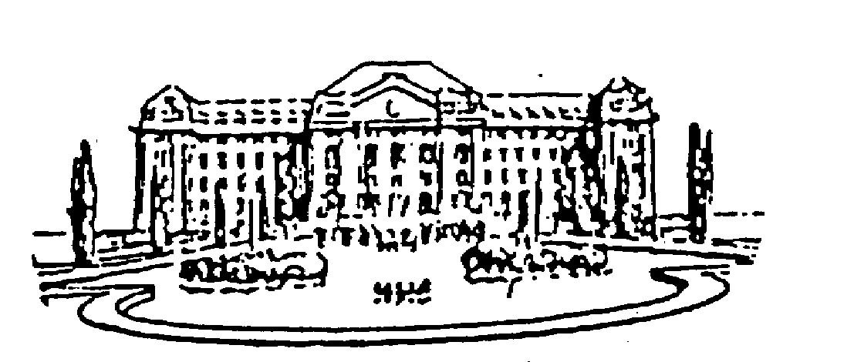
UNIVERSITY OF DEBRECEN
Institute of Physical Chemistry
Debrecen 10, P.O.B. 7
H-4010, Hungary
Tel: (36-52)-512900 Fax: (36-52)-512915

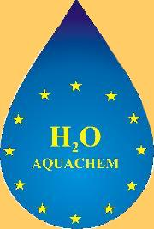
CONSIGLIO Nazionale delle Ricerche
Istituto di Chimica dei Composti OrganoMetallici – ICCOM
Area di Ricerca di Firenze, Building C, room 158
Via Madonna del Piano, 50019 Sesto Fiorentino (Firenze) Italy
Tel +39 055 5225251 Fax +39 055 5225203
Dr Luca Gonsalvi, PhD, MRSC, Email: l.gonsalvi@iccom.cnr.it

Kick-off Workshop of the COST D29/0009/03 Working Group
Green Chemistry through Aqueous Organometallic Catalysis

Kick-off Meeting of AQUACHEM
Transition Metal Chemistry and Catalysis in Aqueous Media
Project RTN n° MRTN-CT-2003-503864

Florence, Italy, February 12-13, 2004.

Location

Istituto dei Composti Organo Metallici – CNR
Polo Scientifico di Sesto Fiorentino
Via Madonna del Piano snc
50019 Sesto Fiorentino (Firenze) – Italy

Local Organizers

Dr. Maurizio Peruzzini, Dr. Luca Gonsalvi
Istituto dei Composti Organo Metallici – CNR
Polo Scientifico di Sesto Fiorentino
Via Madonna del Piano snc
50019 Sesto Fiorentino (Firenze) – Italy
Phone: +39 055 5225 289
Fax: +39 055 5225 203
e-mail: mperuzzini@iccom.cnr.it

Organizer

Prof. Ferenc Joó
Institute of Physical Chemistry
University of Debrecen
Debrecen 10, P.O.Box 7
H-4010 Hungary
Phone: +36 52 512900
Fax: +36 52 512915
e-mail: jooferenc@tigris.klte.hu

Program of the meeting

COST D29

Arrival of the participants: Afternoon/evening of February 11 or morning of February 12.

Day 1: February 12, 2004.

10:30 General discussion of the activity of the Working Group and information concerning the situation of COST-within-ESF
F. Joó (University of Debrecen, Hungary)

12:00 Lunch break

13:45 Gábor Laurenczy (Ecole Polytechnic Federal, Lausanne, Switzerland)
”High pressure studies in aqueous kinetics and catalysis”

14:15 Birgit Driesen-Hölscher (University of Paderborn, Germany)
”Chemo-, regio- and stereoselective hydrogenations in water and ionic liquids”

14:45 Paolo Pelagatti (University of Parma, Italy)
”Potentially tridentate ligands in the synthesis of organometallic compounds.
Synthesis, structure and reactivity”

15:15 Christoph Richter (PSA-DLR, Spain)
”Plataforma Solar de Almería: Largest European Center Devoted to the Technological
Development of Solar Energy Applications”

15:45 Marvelli Lorenza (University of Ferrara, Italy)
”Synthesis, characterization, chemistry and photochemistry of a family of
ruthenium dihydride complexes”

MCRTN AQUACHEM
16:00 Ferenc Joó (University of Debrecen, Hungary)
”Making use of the two largest pools of carbon: CO₂ and carbonate rocks”

16:30 Coffee Break

17:00 Maurizio Peruzzini (ICCOM CNR, Florence, Italy)
Introductory remarks concerning the AQUACHEM consortium

17:15 Maurizio Peruzzini (ICCOM CNR, Florence, Italy)
“New chemistry and catalysis with water-soluble ligands
an overview of the Florence’s team activity and working perspectives”

17.30 Luca Gonsalvi (ICCOM CNR, Florence, Italy)
“Ruthenium (II) water soluble complexes of PTA (PTA = 7-phospha-1,3,5-triazaadamantane) for catalytic biphasic hydrogenations. Mechanistic studies by high pressure NMR and DFT calculations”

18.00 Rinaldo Poli (Laboratoire de Chimie de Coordination, Toulouse, France)
“High oxidation state organometallic chemistry in water.
Results for Cp*Mo and perspectives”

18:30 Antonio Romerosa (University of Almería, Spain)
“New water soluble vinylidene and allenylidene ruthenium complexes
containing water soluble phosphane and Cp”

20:30 Dinner

Day 2: February 13, 2004.

09:30 Anne Marie Caminade (Laboratoire de Chimie de Coordination, Toulouse, France).
”Dendritic catalysts”

10:00 Jenny Gun (The Hebrew University of Jerusalem, Israel)
” Combined on-line electrochemistry/mass spectrometry for the investigation of electrochemical reactions and electrochemically inhomogeneous surface”

10:30 Agusti Lledos (University of Barcelona, Spain)
”Computational Modeling of "Real" Organometallic Chemistry: What Can We Do”

11:00 Coffee Break

11:15 Robin Perutz (University of York, United Kingdom)
” Photoactive supramolecules: phot induced redox chemistry at a remote site”

11:45 Rudi van Eldik (University of Erlangen, Germany)
” Mechanistic insight gained from volume profile analysis”

12:15 Lunch break

14:00 Armando Pombeiro (Istituto Superior Tecnico, Lisbon, Portugal)
”Chemistry and electrochemistry of selected small molecules towards catalysis in aqueous medium”

14:30 Gianna Reginato (ICCOM CNR, Florence, Italy)
”Synthesis of functionalized alkynes as ligands for water soluble unsaturated carbenes”

15:00
- Round Table Discussion:
General discussion of the lectures.
- Identification of joint projects and possible collaborations between teams participating in the COST Working Group and in the MCRTN Consortium AQUACHEM.
- The AQUACHEM Workshops
- Administrative and financial details
- Future meetings

Closure notes

End of the meeting

